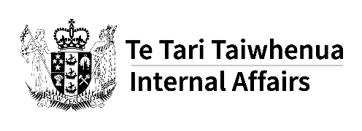
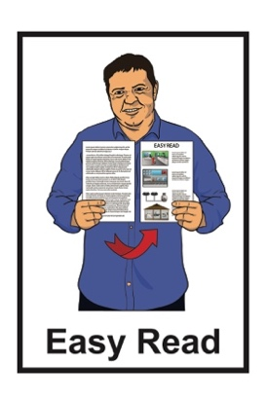

Safer Online Services
and Media Platforms

Published: June 2023

About this document

This document is about new ways for dealing with content that might harm people.

Content means things people share like:
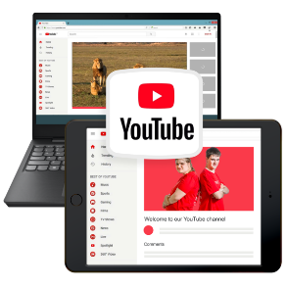
posts on social media like Facebook
videos at places like YouTube
stories in books
- TV or radio programmes
music on the radio or on apps like Spotify.

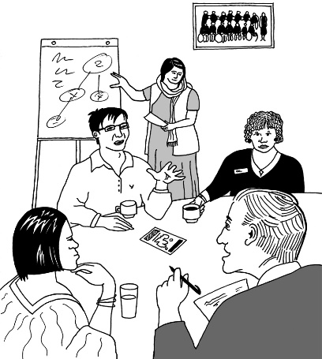
The Department of Internal Affairs has been doing some work on how to deal with harmful content.

The Department of Internal Affairs is part of the Government.

It is also called DIA for short.

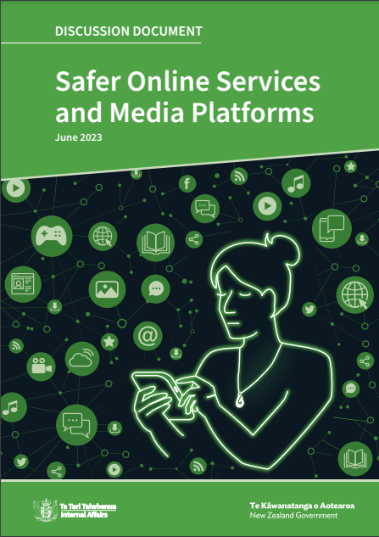
When we say we in this document we mean the DIA.

This is an Easy Read summary of a document called:

Discussion Document: Safer Online Services and Media Platforms

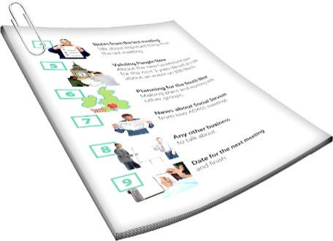
A summary:
is shorter than the main document
includes the main information.

You can find the discussion document on the DIA website at:

www.dia.govt.nz/safer-online-services-media-platforms-consultation
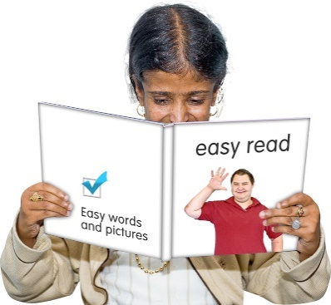

The full discussion document is not in Easy Read.

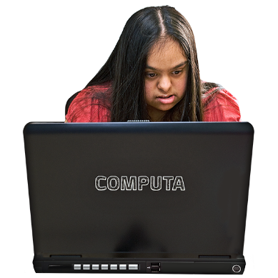
There is also a short video about this work on the same website at:

www.dia.govt.nz/safer-online-services-media-platforms-consultation

Why do things need to change?

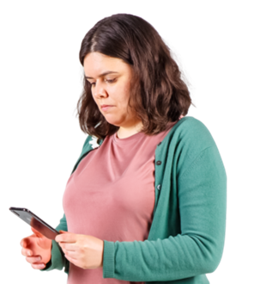
It is much easier for people to make content than it used to be.

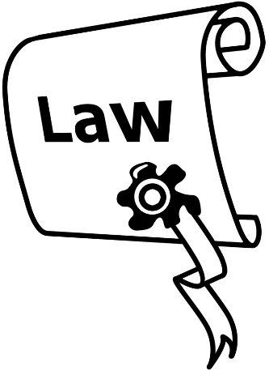
The main laws that regulate content are more than 30 years old.

Regulate means to control how something works.
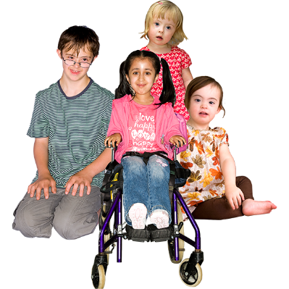

These laws do things that are still important like:
keep children safe from content that is not right for their age
ban / stop some content that can cause a lot of harm.
The main problems are that:
the way things are now does not keep up with new technologies / kinds of content
ways of dealing with problems:
- are too slow
- only happen after someone has been harmed.

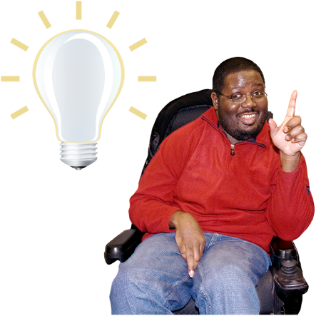
We think there should be a new way of doing things.

We think things should move:
from regulating content
to regulating platforms.

Platforms are places people can put content.

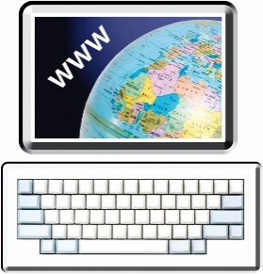
Platforms might be:
TV or radio stations
websites
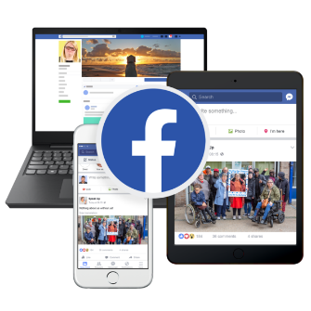
social media like Facebook or TikTok.

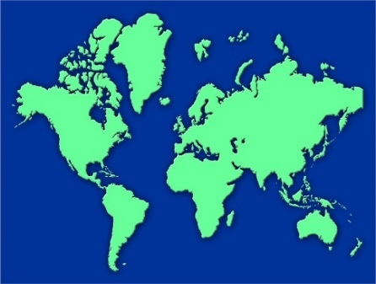
Some platforms like social media are places anyone can post content.

Many other countries have also moved to a new way of doing things.

What should the review do?

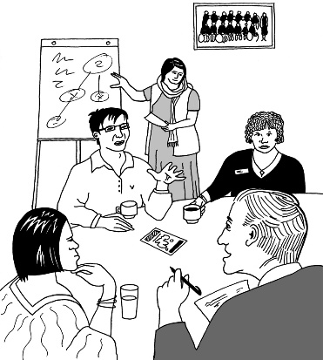
We are having a review of the regulations.

A review is when we:
look at the regulations
find out:
- how they are working now
- what could be done to make them better.
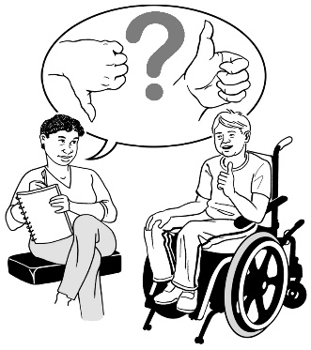

As part of the review we want to know what you think.

As part of the review we want to find a better way of doing things that:
says how much safer platforms should make things
better protects:
- children
- young people
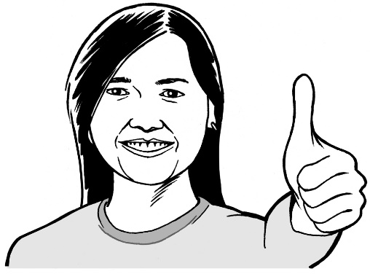
- other people / communities that are more likely to be harmed
means being around content is:
- safe
- inclusive.
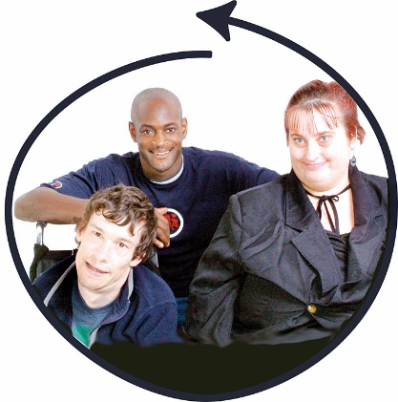
Inclusive means everyone can be a part of it in a way that works well for them.
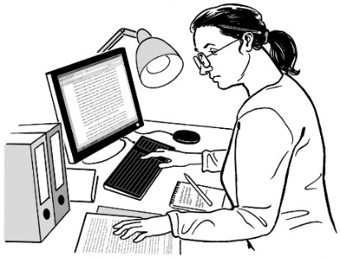
As part of the review we also want to find ways to make things safer without causing problems with important rights like freedom of expression.

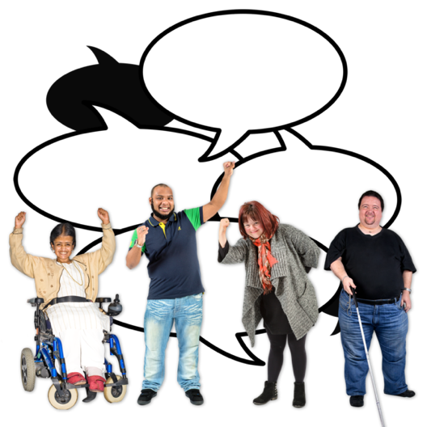
Freedom of expression means having the right to say what you think.

For example you have the right to say you do not agree with the Government.

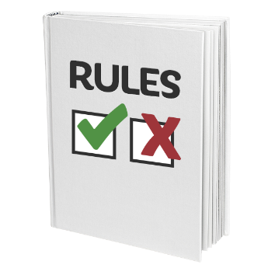
We want to do all this while still keeping to the idea of an internet that is:
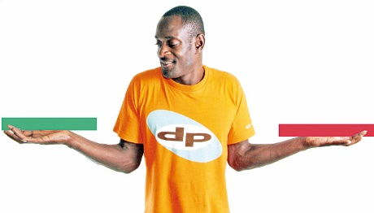
free which means there are not more rules than there need to be
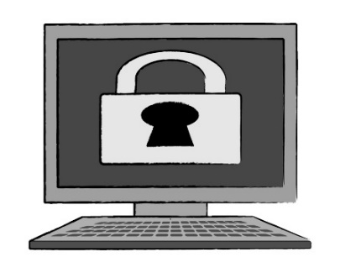
open which means you choose what you see rather than your internet company choosing for you
secure which means information is kept safe.

What we think should happen

We suggest a way of doing things that includes:
education
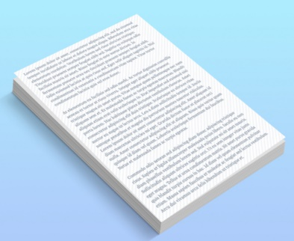
codes of practice
a regulator
laws.
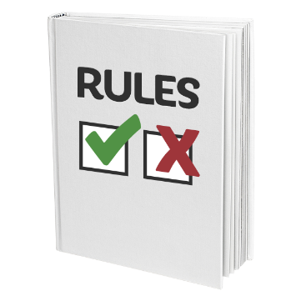

Codes of practice are like rules that platforms agree to follow.

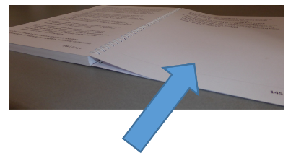
We will look at what a regulator means on pages 13 to 14.

We think this new system will work better because:
it takes some of the things that work well for traditional media like TV and uses them for social media as well
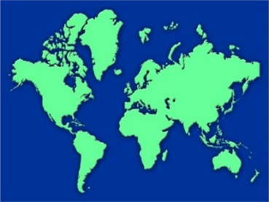
it fits with the way things are being done in other countries
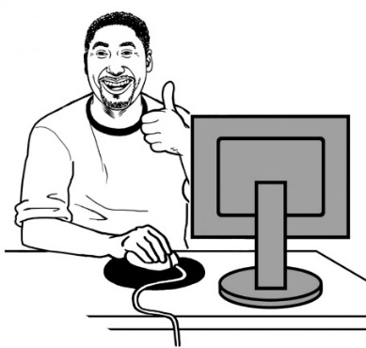
online services will need to have things that mean users can stay safer when using platforms
it be easier for:
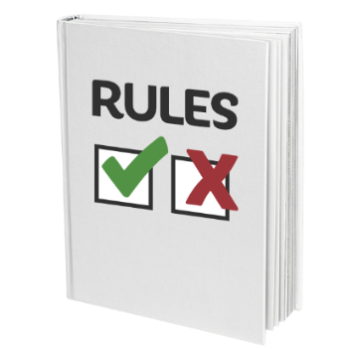
- people to say when there are problems
- platforms to follow the rules.

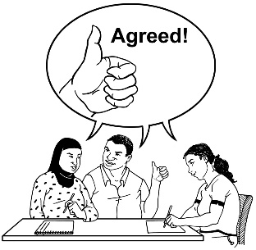
The regulator would have the job of:
agreeing to the codes of practice
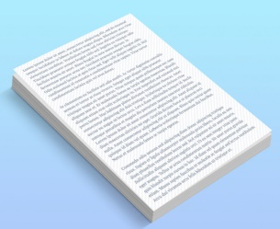
making sure platforms follow the codes
finding good ways to do education.

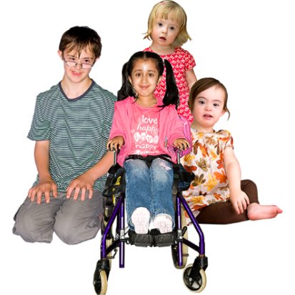
The regulator would focus on where there is most risk like:
harm to children
promotion of terrorism.

Risk means how likely it is things will go wrong.

Terrorism is when a person or group does something violent to scare people like:
hurting / killing people
setting off a bomb.
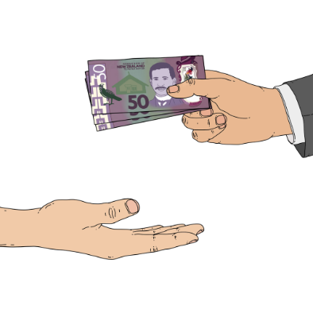

The regulator would also find money to pay for education.

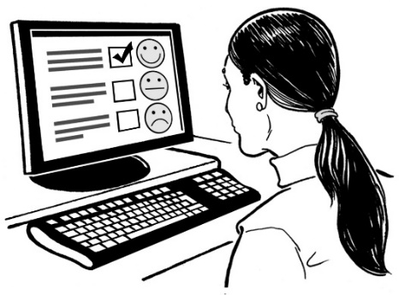
We want to know what you think is the best way of doing things to:
keep people safe
and
protect our:
- rights
- freedom of expression.

Platforms

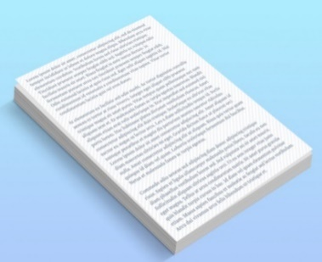
The law would say that some platforms have to:
follow codes of practice
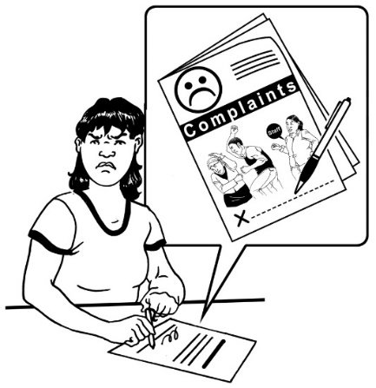
deal with complaints when people find harmful content on their platforms.

A complaint is when you say:
something is wrong
what you want done to fix it.

The platforms that would have to do this are those that are:
bigger than an agreed size
found to be higher risk.

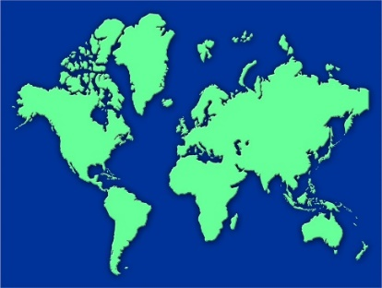
This way of doing things fits with how things have been done in countries that are like New Zealand.

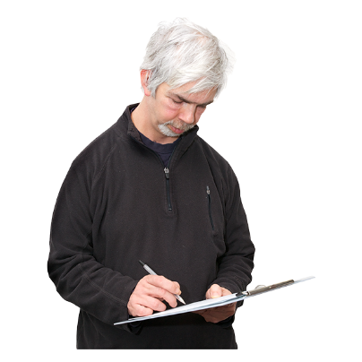
It would make it easier to make sure the new way of doing things is happening.

It also means it will not cost too much to do things right.

Codes of practice

Codes of practice would include ways for:
platforms to remove very harmful content like content that supports terrorism
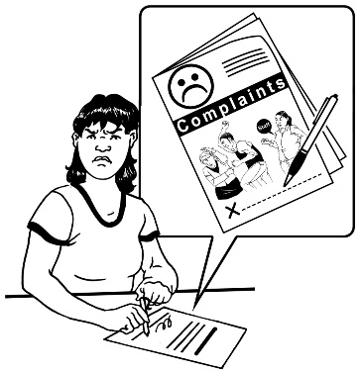
platforms to stop unsafe content being shared as much
people who use the internet to complain about content
platforms to show how things are going.

Codes of practice would also include support for consumers to make informed choices about content that may be harmful.

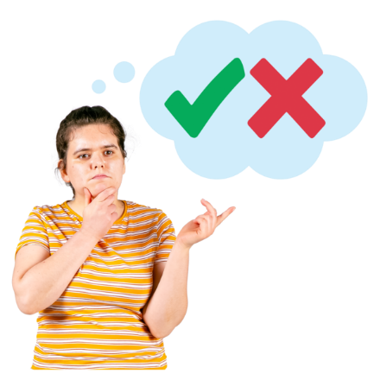
An informed choice is when you:
can choose what you want
have the information you need to understand what you are choosing.

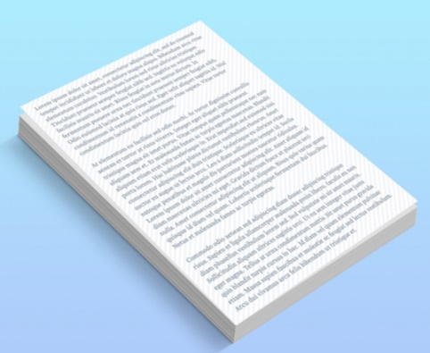
The codes would be made:
by groups of organisations that do work relating to content
with support from the regulator.

The regulator would check that platforms are following the codes of practice.

Education

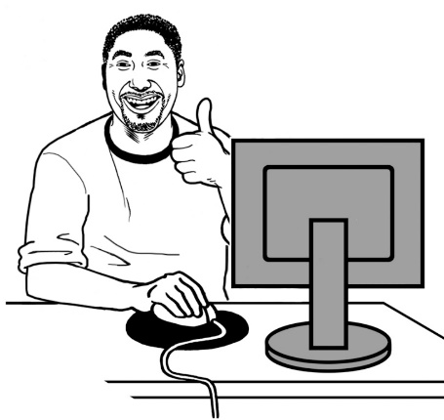
Education would mean people could learn:
about the problems with making / watching harmful content
how to use the platforms more safely.

Illegal content

Some content in New Zealand is:
censored
breaks other laws.

Censored means it is banned / stopped because it is very harmful.
There are already ways to make sure illegal information is removed / taken down.

These ways will be moved to the new way of doing things.

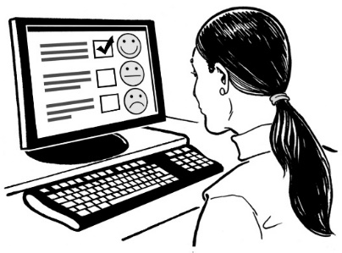
We want to know if you think there should be the same ways of making sure information is removed / taken down if that information breaks other laws.

An example of how things might work

This is an example of how things might work with the new way of doing things.

This example is to do with eating disorders.

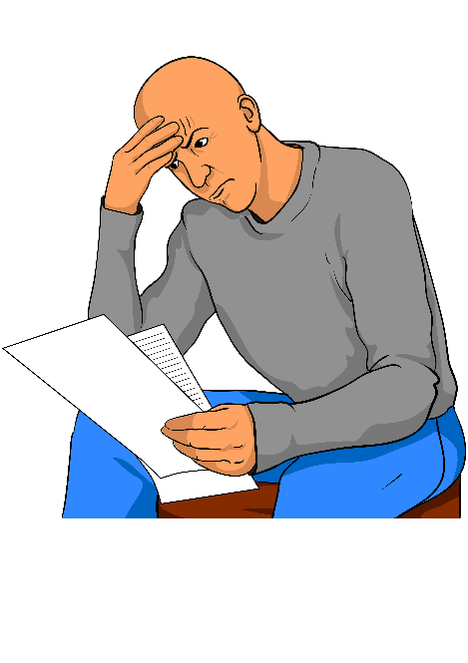
Reading about eating disorders can be upsetting.

If you do not want to read this part you can go to page 26.

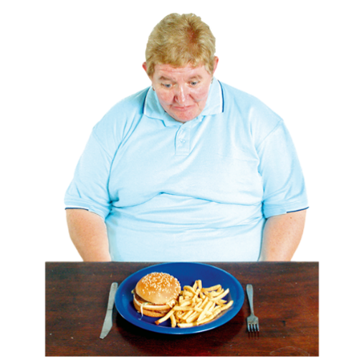
Eating disorders are mental health conditions to do with eating.

For example some eating disorders mean people do not eat as much food as they need.

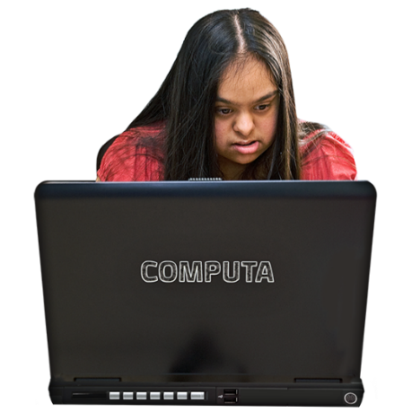
Sometimes people put information on the internet that tells people they should make their eating disorder worse.

For example it might tell them:
how to eat less
ways to keep their eating disorder secret so they do not have treatment.

This content can cause a lot of harm.

In the new way of doing things there could be support available like:
information that lets you decide if you want to see the content
education for people who make content about the risks of making this sort of content
education in places like schools about:
- why this content harms people
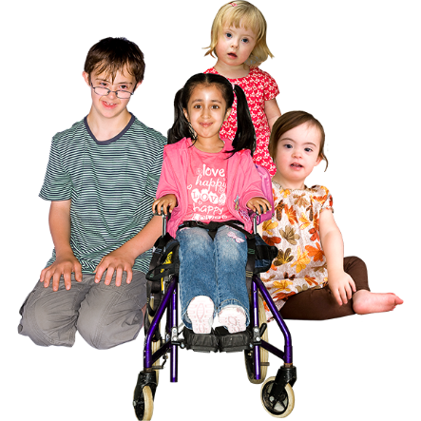
- how best to support people with eating disorders.

There would also be rules for platforms about not promoting this content to children / young people.

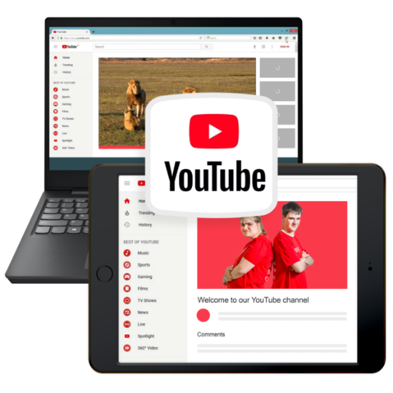
Promoting is when a platform tells you about content you were not looking for.

For example if you watch a video it might tell you about other videos to watch.

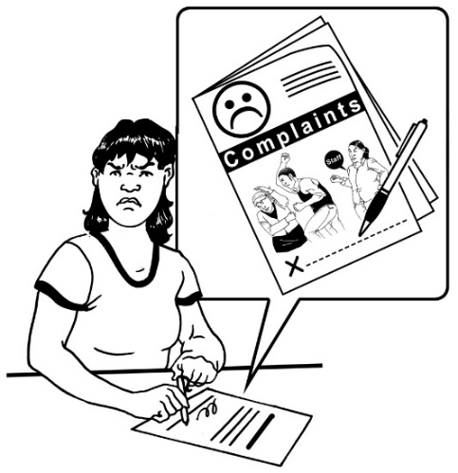
Platforms would have to deal with complaints if this content broke their rules.

Platforms could also look at what information is recommended.

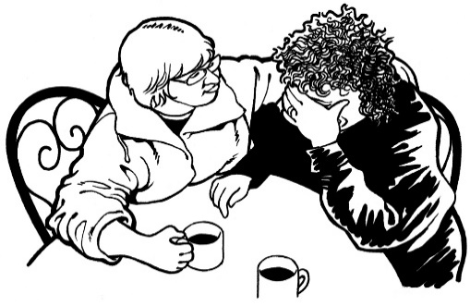
For example if someone searches for information about eating disorders then supportive information would be shown first.

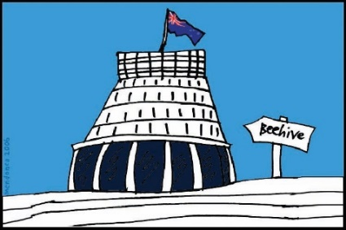
Another way of doing things would be for the Government to tell the platforms they have to stop people seeing this content.

We do not think this is a good way of doing things.

Have your say

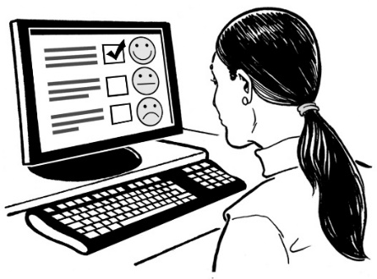
We want to know what you think about these ideas.

You can tell us what you think by:
sending us an email to:
sosmp_consultation@dia.govt.nz

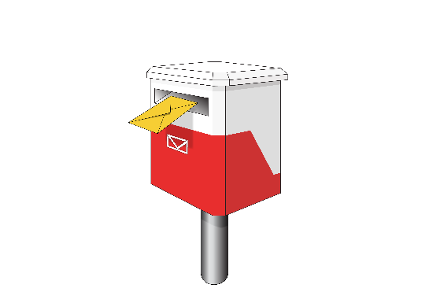
writing to us at:
Safer Online Services and Media Platforms
Department of Internal Affairs
PO Box 805
Wellington 6140
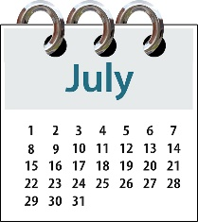
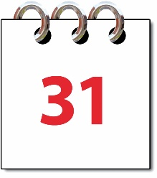
The last day to tell us what you think is:

Monday 31 July 2023.

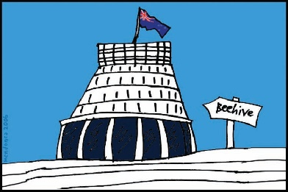
We will use the things you tell us to:
give the Government ideas to think about
make decisions about what should come next.
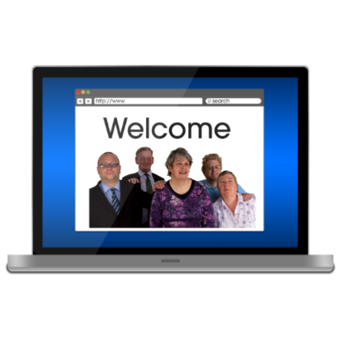

We may put what you say on our website.

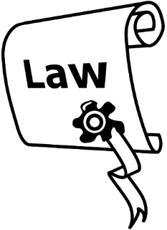
We may also have to tell people what is in your submission because of a law called the Official Information Act.

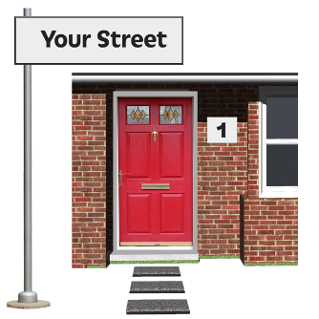
We will not tell people your contact information like your:
address
email address
phone number.
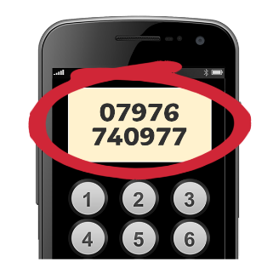

If you want us to keep anything else private you need to tell us:
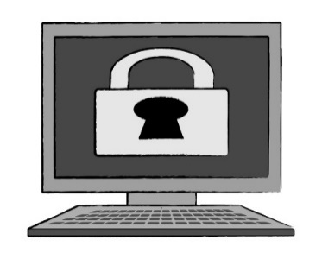
what you want to keep private
the reasons why.

This information has been written by the Department of Internal Affairs.

It has been translated into Easy Read by the Make it Easy Kia Māmā Mai service of People First New Zealand Ngā Tāngata Tuatahi.

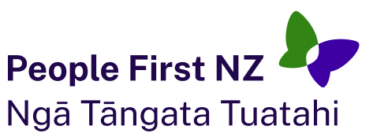
The ideas in this document are not the ideas of People First New Zealand Ngā Tāngata Tuatahi.

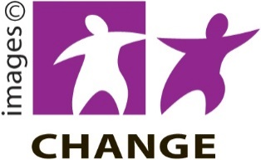
Make it Easy uses images from:

- Changepeople.org

- Photosymbols.com

- SGC Image Works

- Huriana Kopeke-Te Aho.
All images used in this Easy Read document are subject to copyright rules and cannot be used without permission.

