2016 Gambling Sector

Survey
Summary of findings

Foreword

Becoming a more effective regulator
This annual survey of stakeholders in the Class 4 sector is a valuable tool to measure how our strategic direction and work as the gambling regulator is perceived.
This is particularly important at a time of change. Over the past year legislative and regulatory amendments have meant the sector has had to adjust and adapt to a number of new ways of working – not least in the way venue payments are calculated.
We, as the gambling regulator, are of course also involved in these changes. At the same time we are also striving to become a really responsive risk based regulator.
To drive this direction we have established a cohesive strategic framework, with our Class 4 vision and objectives at its core.
This survey is the first to assess how stakeholders view our approach to regulation using the vision and objectives to drive our work.
We will therefore be able to test our progress against a set standard of questions in following years.
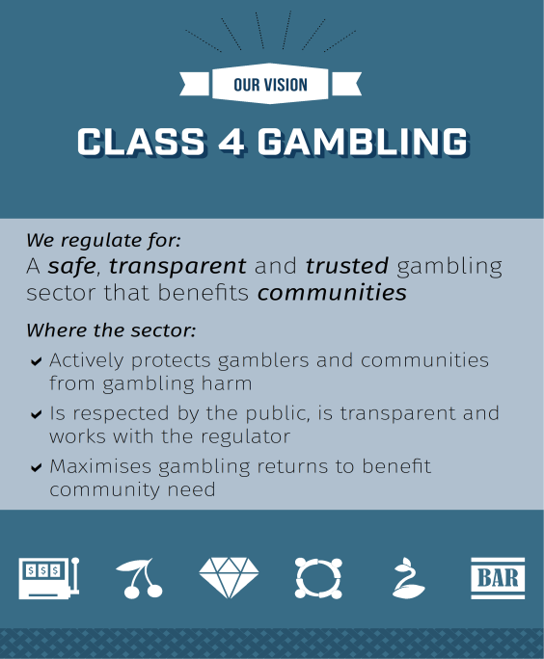 | 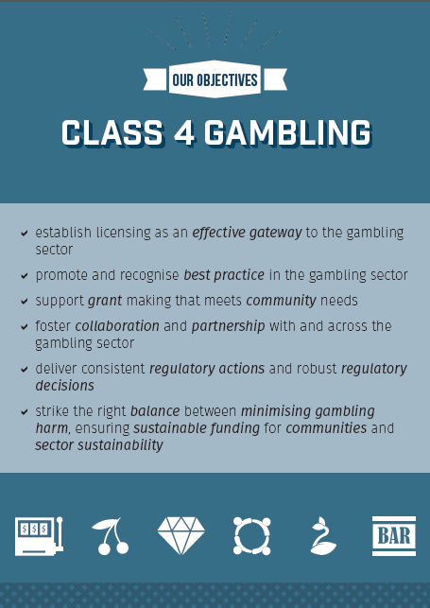
In response to the survey questions around our vision there was agreement or strong agreement (73 per cent) that the sector is working constructively with the regulator to achieve compliance.
This reflects the progress we have made to change our approach to engaging with stakeholders so that we listen and collaborate effectively in order to make smarter decisions.
Seventy per cent agree or strongly agree that Internal Affairs is meeting its objective of establishing licensing as an effective gateway to the gambling sector. While 50 per cent of respondents agree or strongly agree that we are striking the right balance between minimising harm, sustainable funding for communities and sector sustainability.
With the changes we are making to our strategic direction and internal approaches it is particularly pleasing to see the ratings for our professional performance have all increased from the 2015 survey. Seventy-eight per cent of respondents rate the quality of information we provide as good or very good, and 70 per cent rate the ease and speed of obtaining information as good or very good.
Our focus on strengthening relationships across the sector means we are working together in new ways and expanding our networks to better connect different groups to build professional working relationships. This includes societies, clubs, venues, management service providers, problem gambling service providers, Hospitality NZ, representatives from territorial authorities, the Health Promotion Agency and the Ministry of Health.
I would like to thank all of you who contribute to making the changes positive and progressive, in participating openly, with the shared objective of benefiting and protecting communities. I ha ve seen willingness from the sector to work openly with us and that is reflected in the positive responses we have received in this stakeholder survey.
I look forward to continuing to work with you to ensure that communities are at the forefront of what we do.
There will continue to be changes over the coming year and I look forward to seeing how those are reflected in future surveys.
Gareth

Gareth Bostock
Director Gambling Compliance Group

Contents
Executive summary 1
Our survey approach 3
Survey results summary 6
Types of organisations 6
Contacting the Department 7
Professional performance 9
Providing information to the sector 11
Approach to regulation 14
Areas of interest or concern 20
Conclusion 21

Executive summary
The Department of Internal Affairs’ (the Department) annual survey of its Class 4 gambling stakeholders was carried out in September 2016. This aimed to build on our previous surveys of stakeholders, as well as introduce some new questions to help understand how the Department’s approach to regulating the Class 4 gambling sector is viewed.
The responses to this year’s survey reveal that improvements have been seen in some areas, particularly relating to engagement between the Department and the sector.
The survey also shows areas where we could place greater focus to ensure that we are being effective regulators and are responding to the needs of our stakeholders.

Contacting the Department
Of those who responded to the survey, 76 per cent had made contact with the Department in the previous 12 months. As in the 2015 survey, email was the preferred way to contact us and the most common reason for contact was licensing applications.

Professional Performance
Overall we received a positive response about the professionalism of our performance. Stakeholders generally find it easy to obtain information from us, and believe that the information they receive is of good quality and provided in a timely manner. There was an increase in positive ratings for all of these questions compared to last year’s survey.
However, 10 per cent of respondents did rate the speed of response as quite slow or very slow. It is also noted that Class 4 non-club societies find information easier to obtain compared to other stakeholder groups.

Providing Information to the Sector
Responses about the Gambits newsletter were very positive. This included ratings about its usefulness, the respondent’s satisfaction with its frequency, the relevancy of the information, and how simple it is to understand. Some comments did suggest that we still need to consider how to ensure that all information is easy to understand, particularly for some sector groups such as Clubs.
The usefulness of our other methods of communication (website, sector forums, and face-to-face meetings) was also rated highly.

Approach to Regulation
We asked questions relating to our vision and objectives for the Class 4 gambling sector.
Responses to the three questions relating to our vision received increased levels of agreement compared to last year, with the most positive responses relating to the sector working constructively with us to achieve compliance. This was also the survey question with the greatest improvement from 2015. A number of comments throughout the survey also referred to an improvement in this area.
Questions about our objectives were introduced in this year’s survey. The objective which respondents were most likely to agree with related to establishing licensing as an effective gateway to the gambling sector.
The objective with the highest proportion of disagree or strongly disagree responses was about striking the right balance between minimising gambling harm, ensuring sustainable funding for communities and sector sustainability. The free text comments relating to this question acknowledged the difficulties involved with this objective and finding the right balance.

Our survey approach
The sections below explain our approach to the 2016 Gambling Sector Survey (the survey).

Survey Purpose
The Department is responsible for the regulation of gambling in New Zealand so that it is safe, fair, legal and honest Stakeholders in the Class 4 gambling sector comprise a diverse range of organisations and individuals. As a responsible regulator, the Department is interested in understanding stakeholder views on their experience engaging and communicating with us.
An annual gambling stakeholder survey has been conducted by the Department since 2009. Over this time the main purpose of the survey has consistently been to measure stakeholder perception of and satisfaction with our professional performance as a regulator. We also want to understand how our approach to regulation is perceived by stakeholders.

Survey constraints
The survey has been modified from year to year to align with areas of focus and to provide information to help us in our approach as a responsive regulator.
Due to changes in the survey tool and sample, longitudinal trends have not been emphasised. In particular, this year some new questions have been added to the survey and there have also been some changes to the stakeholder group invited to complete the survey.

Survey sample
The survey was designed to be answered by a range of stakeholders within the Class 4 gambling sector in New Zealand. Last year we invited Territorial Authorities and some additional service providers to complete the survey for the first time. These groups were included again in 2016. We also continued to include Class 4 non-club societies and clubs. This year however, we asked each Class 4 non-club society to fill in only one survey. This was in contrast to previous years when we received responses from several people in the same organisation. All responses are anonymous. The inclusion of a question identifying the type of organisation being represented provided us with the option to consider this as part of our analysis.
Stakeholders from the casino sector were not included in this survey sample.

Invitation to participate
Email invitations to participate in the web-based survey were sent to 400 individuals, representing 378 organisations.
The Department’s Gambling Compliance Group has regular contact with a number of our stakeholders and as a result holds contact detail information for them. These details, along with publicly available contact information for additional stakeholders, were used to compile a list of potential participants.

Response rate
Email invitations were sent to 400 individuals and 171 responses were received. This represents a response rate of 43 per cent.
Figure 1: Response rate, by organisation type.
Organisation Type | Number of organisations | Number of invitations sent | Number of responses | Response Rate
Class 4 non-club society | 34 | 34 | 26 | 76%
Clubs | 247 | 247 | 91 | 37%
Territorial Authorities | 72 | 72 | 37 | 51%
Other stakeholders | 25 | 47 | 17 | 36%
Total | 378 | 400 | 171 | 43%
Figure 1 shows the number of invitations sent to stakeholder groups and the response rate for each.
In 2015, 413 stakeholders were invited to participate and 233 responded, resulting in a response rate of 50 per cent. In 2014, 317 stakeholders were invited to participate and 151 responded, which is a response rate of 48 per cent.

Survey timing
The survey was open for responses for a period of two weeks from 1 September to 14 September 2016. Reminder invitation emails were sent at the mid-point and also two days before the survey closed.

Survey design and results
The survey had 19 questions. Various question formats were used; fixed, rating scale and multi-choice. Up to 16 questions required selection/s from a choice of answers, a number of these also allowed for specific free text comments to be added. Three optional, free text questions provided an opportunity for comment in specific areas. A copy of the survey questions is included on the Department of Internal Affairs’ website.
Eleven questions use a five-point ‘Likert-like’ agree scale. The middle of the scale is identified as average or neutral, with the extremes indicating either strong agreement or strong disagreement with the question or proposition.
A sample of comments from open ended questions is included so that where applicable some context may be seen in the answer. While it is impractical for all comments to be included, samples have been selected to show the variety of views expressed. The number of examples and total number of comments are shown in brackets after each question.

Survey results summary

Types of organisations
Question 1: What type of organisation are you completing this survey on behalf of?
Figure 2: Organisation type
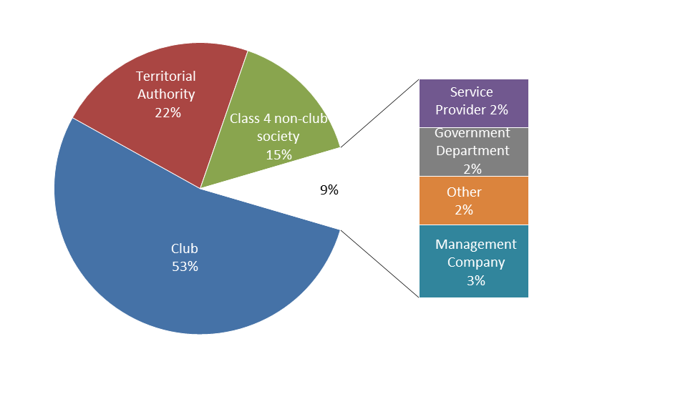
Figure 2 shows the percentage of respondents from each organisation type.
The majority of respondents is from Clubs (53 per cent), followed by Territorial Authorities (22 per cent) and Class 4 non-club societies (15 per cent).
This year’s approach in seeking only one response per Class 4 non-club society has resulted in this group representing a smaller proportion of respondents than in 2015 (down from 20 per cent). There was an increase in Territorial Authorities from 14 per cent in 2015 to 22 per cent this year.
These differences have an impact on the ability to make direct comparisons between the 2015 and 2016 results.

Contacting the Department
Question 2: How do you prefer to contact the Department’s Gambling Compliance Group, should you need to?
Figure 3: Preferred contact method
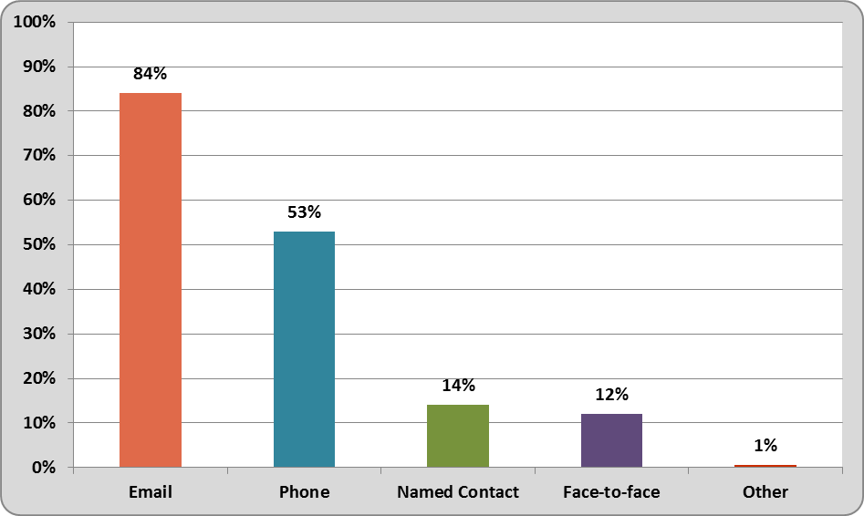
Figure 3 shows the percentage of respondents who selected each of the contact options.
Respondents were able to choose more than one preference and a total of 279 selections were made by 169 respondents.
Email (84 per cent) is the preferred method of contacting the Department followed by phone (53 per cent). This follows a similar overall pattern to 2015 where email (87 per cent) and phone (53 per cent) were the most popular choices.
The preference for a named contact has remained the same (14 per cent) for 2015 and 2016 but the preference for face-to-face contact has dropped from 17 per cent last year to 12 per cent this year. The overall drop in the proportion of respondents who were from Class 4 non-club societies may be a contributing factor here as they are more likely to regularly meet with representatives from the Department compared to other stakeholder groups.

Question 3: Have you contacted the Department over the past 12 months?
The majority of the respondents had contacted the Department over the past 12 months (76 per cent). A very small proportion (less than 6 per cent) of respondents answered “not sure”.
We asked respondents who answered yes to question three to provide information about their experiences of contacting us (questions 4 to 7).

Question 4: Tell us why you have contacted the Department over the past 12 months.
Figure 4: Reasons for contact
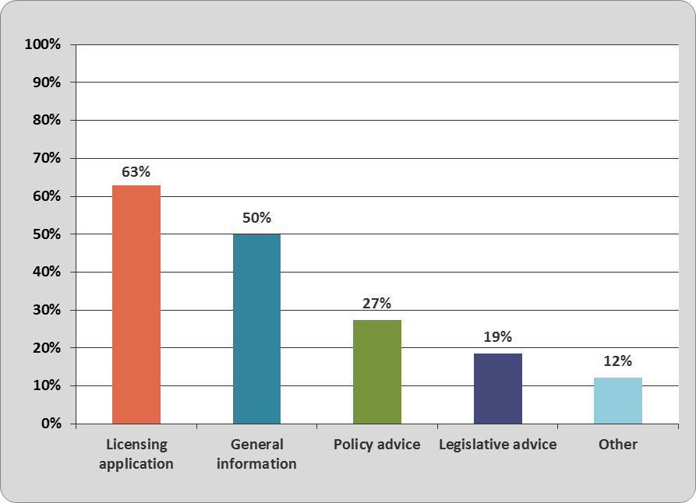
Figure 4 shows the percentage of respondents who selected each reason for contact.
Respondents were able to choose more than one reason and 212 selections were made by 124 respondents. This indicates that some individuals have contacted us for a variety of reasons.
The two most common reasons for contacting the Department were licensing applications (63 per cent) and general information (50 per cent). The highest number of contacts is received from Clubs followed by Class 4 non-club societies. Respondents from Territorial Authorities indicated a variety of reasons for contacting us, although most commonly for general information and policy advice.
Audit, technical standards and submissions were some themes for a number of entries in the “other” category.

Professional performance
Those respondents who had contacted us in the past 12 months were asked the next three questions about their experiences of contacting the Gambling Compliance Group for information.
Question 5: In general, how easy have you found it to obtain the information you need from us?
Question 6: In general, how would you rate the quality of information provided by the Department?
Question 7: In general, how would you rate the speed of our response to you?

These have been grouped together in our analysis to evaluate our professional performance. The questions use rating scales from 1-5, with 1 being the highest and 5 the lowest.
For example:
1 – Very easy
2 – Quite easy
3 – Average
4 – Quite difficult
5 – Very difficult

Figure 5: Professional performance
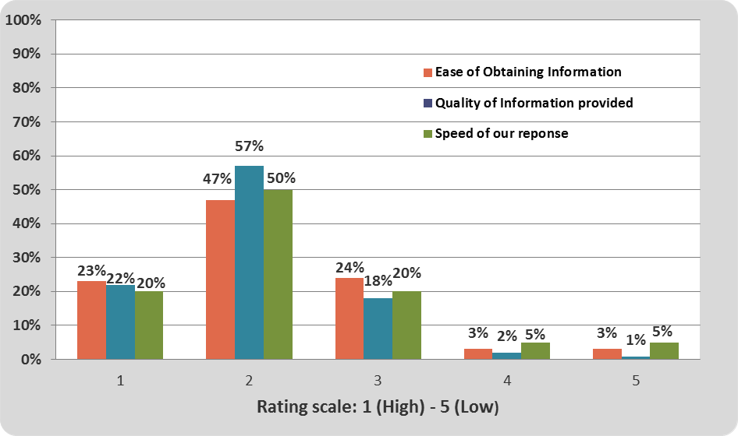
Figure 5 shows the percentages for selections for each of the three questions rating our professional performance.

The responses across all three questions were all very positive with:
- Seventy per cent rating the ease of obtaining information as very easy or quite easy
- Seventy-eight per cent rating the quality of information provided as very good or good
- Seventy per cent rating the speed of response as very fast or quite fast.

Compared to last year, this is an increase in the positive ratings in all three areas of our professional performance.
It is pleasing to see that only three per cent of respondents rated information provided as being of poor or very poor quality, although 10 per cent did rate the speed of response as quite slow or very slow.
The results show that Class 4 non-club societies found it the easiest to obtain information from the Department, followed by Clubs.

Question 8: If you have any specific comments about your experience of contacting us please add them here.
A number of comments reflected that the sector has seen improvements in their contact with the Department, as well as finding it particularly beneficial when they have a named person that they can contact. Some people also reported that it can be difficult to get in touch via telephone or slow to get a response when a message is left.
A sample from the 30 comments received is provided (5/30):
“Specific information requested was provided, exactly as expected. Interim reply received explaining likely time frame which was helpful.”
“Much better now than in the past. There seems to be a culture of working together recently.”
“It’s very hard to get an actual person on the telephone. Once you get the person, the service is consistently excellent”
"I have liaised with one person and that has worked extremely well. My past experience was with ringing and leaving electronic messages that they were not returned”
“Friendly - Helpful - Constructive”

Providing information to the sector
We are interested in perceptions of how useful our current communications are in providing information to the sector. We asked respondents to indicate which they have used and rate how useful they have found each source.

All information sources
Question 9: The Department provides general information to the sector in a number of ways. Please tell us how useful you have found these sources of information in the past 12 months.
Figure 6: Usefulness of information sources

Figure 6 shows percentages for the ratings of four of the main sources we use to provide information to the sector.
Note: Respondents were also given the option of “haven’t used”. Those who chose this response are not included in the calculation of percentages in this figure.

Gambits Newsletter
A very high number of respondents had received Gambits (88 per cent).
About 86 per cent of those found Gambits very useful or useful and this reinforces its value as an information source for the entire sector.
Compared to other sources of information this had the highest percentage of very useful or useful responses.

The Department’s Website
Almost all of the respondents to this question had used the website (92 per cent) and of these, more than three-quarters of respondents who used it rated it as useful or very useful (78 per cent).
However, this was also the information source with the greatest percentage of respondents who found it either “a bit useful” or “not at all useful” (10 per cent and 1 per cent respectively).
Sector Forums
Sector forums are regional meetings targeted at Class 4 non-club societies and key stakeholders for the purpose of engaging with the sector and exchanging information.
Almost half (49 per cent) of our survey respondents indicated that they had been involved in a sector forum.
Of the 71 respondents who rated sector forums as a source of information, 61 per cent indicated that they found them useful or very useful. Only three per cent of those who had attended a forum in the past 12 months rated them as a bit useful or not at all useful.
Face-to-face meetings
Sixty per cent of respondents had been involved in a face-to-face meeting over the past 12 months. Of those, the majority rated the experience as useful or very useful (76 per cent).

Gambits Newsletter
Further specific questions to find out about the level of satisfaction, relevance and simplicity of the information in Gambits (questions 10, 11 and 12) were asked. Any respondent who indicated in question 10 that they did not receive Gambits was not asked to respond to questions 11 or 12.
Very high levels of positive ratings have been received for all three of these questions.

Question 10: How satisfied are you with the frequency of the Gambits newsletter?
Satisfaction ratings for its frequency were high, with 74 per cent of respondents being satisfied or very satisfied. This pattern is similar to the ratings received last year which was 71 per cent.

Question 11: Is the information in the Gambits newsletter relevant to you?
Over 90 per cent of the respondents rated the newsletter as being relevant to them.

Question 12: How simple is it to understand the information in the Gambits newsletter?
Figure 7: Simplicity of Information
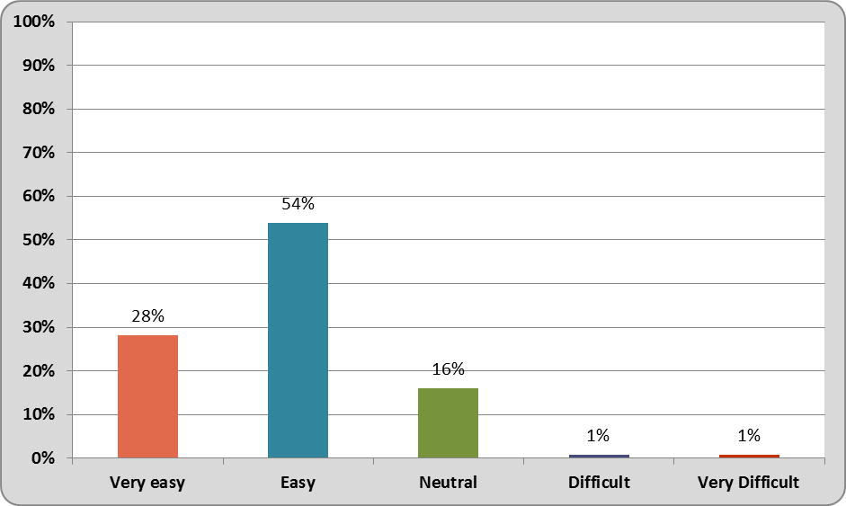
Figure 7 shows the percentage of responses for each selection.
Over 80 per cent of the respondents found it either very easy or easy to understand the information provided in Gambits.
Only a very small percentage of respondents found it difficult or very difficult (2 per cent).

Question 13: If you have any comments about how the Department communicates information to the gambling sector and/or the content of information provided please add them here.
In general the comments showed that respondents were satisfied with how information is being provided and the content. However, it was highlighted by some respondents that information could be clearer, especially for those with less knowledge of the relevant legislation and regulations.
A sample from the 24 comments received is provided (3/24):
“Gambit is a fantastic communication tool, just sometimes; it is very confusing with all the legislation to comprehend. When you are a club manager with limited resources, it can be difficult to investigate further all the new changes and what they mean to our class 4 license. [sic]”
“Only comment is that all information received is very useful and staff very helpful.”
"Forums are excellent and even better consultations involving a range of stakeholders, so everyone is on the same page and there is the opportunity for a cross fertilisation of views…”

Approach to regulation
We wanted to gauge sector perceptions of our approaches to some key areas for us as a regulator. The following three questions relate to our vision for the sector.
Question 14: To what extent do you agree that the sector is actively protecting gamblers and communities from gambling harm?
Question 15: To what extent do you agree that the sector is working constructively with the regulator to achieve compliance?
Question 16: To what extent do you agree that the sector maximises gambling returns to benefit community need?

Figure 8: Vision statements
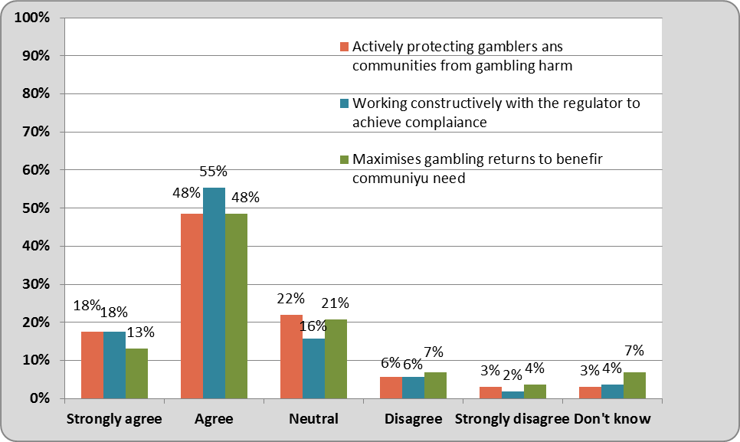
Figure 8 shows the percentage of selections for each rating option for all three questions asked.
In general responses were similar for all three questions.
The most positive responses related to the sector working constructively with the regulator to achieve compliance, with 73 per cent agreeing or strongly agreeing with this statement. This compares with 66 per cent agreeing or strongly agreeing that the sector actively protects gamblers and communities from gambling harm, and 61 per cent agreeing or strongly agreeing that the sector maximises gambling returns to benefit community need.
The highest percentage of disagree or strongly disagree responses related to maximising gambling returns to benefit community need (11 per cent). This question also had the highest proportion of those who responded ‘don’t know’ (7 per cent).
Responses to all three questions were more positive than last year with the largest increase for question 15 (working constructively with the regulator) where there was an increase from 63 per cent agreeing or strongly agreeing to 73 per cent this year.
Between groups, Clubs and Class 4 non-club societies largely selected agree or strongly agree. Territorial Authorities were more likely to select neutral as their response.
The opportunity to provide specific comments relating to these questions was offered.

Gambling Harm
A number of comments referred to societies and venues having the tools and support they need to minimise harm. However, there were also comments referring to problem gambling service providers not doing enough, and that there should be a greater focus on personal responsibility and fewer obligations on venues.
A sample from the 27 comments received is provided (3/27):
“I believe that the large majority of Clubs are very mindful of practising harm minimisation with their members, in that they know their members and who is using the gaming machines. I struggle that a number of Public access venues do the same.”
“Providers are useless and ineffective. Societies and venue operators are mostly taking this very seriously. There is not enough proper support for problem gamblers who present themselves to providers. This is an area of major failure and yet it is very well funded.”
“…The recent initiative with HPA has made harm min processes more accessible to those who have to apply them on a day to day basis. Well done!”

Partnership
There were mostly positive comments in relation to this question, although some raised the point that some operators are less likely to engage and need increased scrutiny from the Department.
A sample from the 20 comments received is provided (2/20):
“I agree the sector is working constructively with the regulator. I have observed situations where both parties have been instrumental in sorting out issues.”
“The compliant operators within the sector are willing to engage with the Department in order to find solutions and shape relevant policy, the operators that work on the fringes will continue to be disengaged and should receive much more in-depth scrutiny from the regulator.”

Community Benefit
The range of comments relating to this question reflected the different points of view of the stakeholders surveyed. Some common themes included the impact of costs on returns to communities and that more money should go back to the local communities in which the gaming machines are located.
A sample from the 26 comments received is provided (3/26):
“I believe that there are costs associated with gaming policy that affects the return to the community. The only winners being administrators and gaming companies.”
“It should not take gambling revenue for this purpose. This "legitimises" the gambling insofar as you get this Lotto type theme of you are helping the community even though you are a problem gambler.”
“Again everyone is working towards the common goals trying to increase efficiencies.”

Question 17: To what extent do you agree that the following objectives for the gambling sector are being met by the Department?
This is a new question introduced this year to gather views on how we are tracking against meeting our objectives, which were rolled out in late 2015. These six objectives help to guide our work in the gambling sector.
Objective One: Establish licensing as an effective gateway to the gambling sector
Objective Two: Promote and recognise best practice in the gambling sector
Objective Three: Support grant making that meets community needs
Objective Four: Foster collaboration and partnership with and across the gambling sector
Objective Five: Deliver consistent regulatory actions and robust regulatory decisions
Objective Six: Strike the right balance between minimising gambling harm, ensuring sustainable funding for communities and sector sustainability

Figure 9: Meeting Objectives
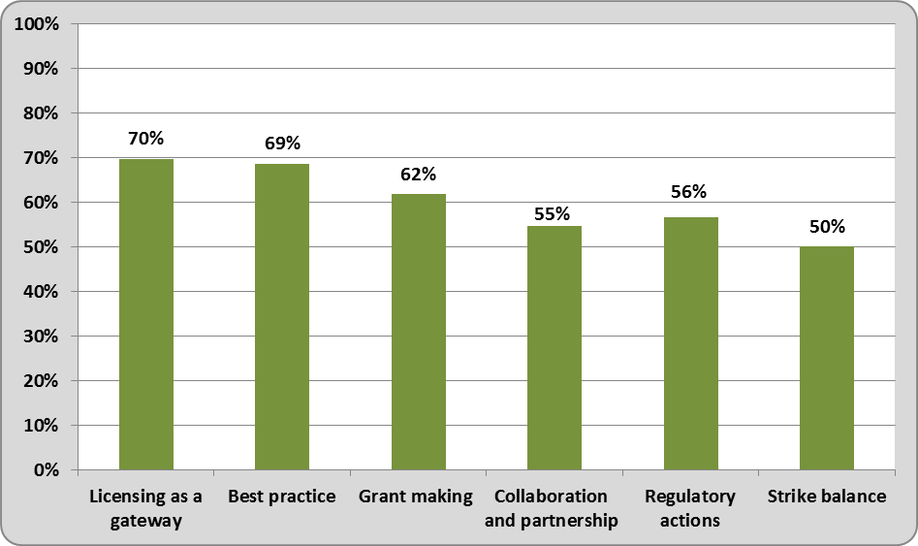
Figure 9 shows the combined percentage of respondents who selected ‘agree’ or ‘strongly agree’ for each objective.

Figure 10: Meeting Objectives
Objective | Strongly agree | Agree | Neutral | Disagree | Strongly disagree
1: Licensing as an effective gateway | 18% | 52% | 22% | 7% | 1%
2: Promote and recognise best practice | 14% | 55% | 24% | 7% | 1%
3: Grant making that meets community needs | 7% | 55% | 31% | 7% | 1%
4: Collaboration and partnership with and across sector | 11% | 44% | 36% | 7% | 2%
5: Consistent regulatory actions and robust regulatory decisions | 9% | 47% | 31% | 9% | 3%
6: Balance between minimising harm, sustainable funding for communities and sector sustainability | 10% | 40% | 3% | 14% | 3%
Figure 10 shows the percentage for selection for each objective.
The response patterns across all objectives were quite similar. The most common response for each was “agree” followed by “neutral”. Clubs and Class 4 non-club societies were more likely to agree that the Department is meeting their objectives than other stakeholder groups.
The objective with the highest proportion of respondents who strongly agreed with the statement was related to establishing licensing as an effective gateway to the gambling sector. While the objective with the highest proportion of disagree or strongly disagree responses was about striking the right balance between minimising gambling harm, ensuring sustainable funding for communities and sector sustainability.
The opportunity to provide specific comments was offered. A number of comments referred to the difficulties of balancing harm minimisation with funding for communities and sector sustainability.
A sample from the 17 comments received is provided (3/17):
“There is far too much focus on “harm” compared with sustainability yet by any objective measure few people are in fact exposed to harm through gambling…”
“There is no evidence that it is possible to minimise gambling harm while also ensuring sustainable funding for communities if the source for that is poker machine trusts…”
“DIA have been open minded in all conversation with regard to sustainability and how this needs to look”
Question 18: In general the Department’s decisions are clearly communicated to my organisation.
Figure 11: The Department’s decisions
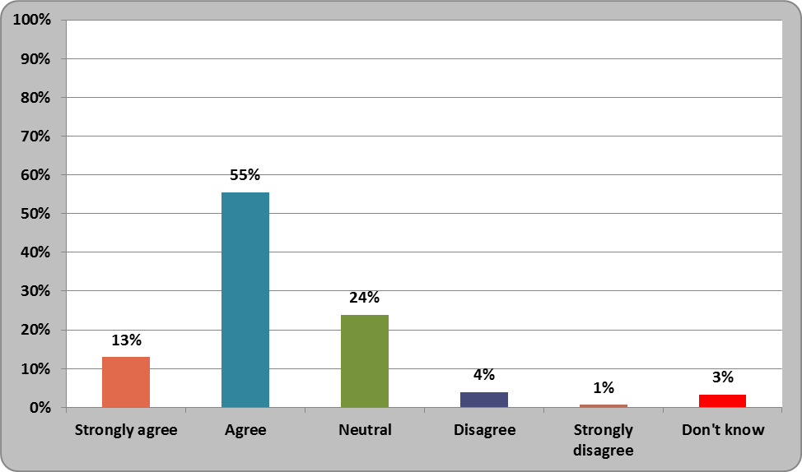
Figure 11 shows the percentage of selections for each rating option.
Over two-thirds of individual respondents agree or strongly agree (68 per cent), while only a small number of respondents disagree or strongly disagree (5 per cent). This is very similar to last year when 66 per cent responded agree or strongly agree and 6 per cent disagree or strongly disagree.
The opportunity to provide specific comments was offered. A sample from 11 comments received is provided (2/11):
“Not all the time or timely. Should be communicated immediately once known.”
“The advice and DIA input to any of my enquiries over the year has been of a high quality and delivered in a professional manner.”

Areas of interest or concern
Question 19: Please tell us about any areas of interest or concern that you feel are currently overlooked but you would like the Department to consider focusing on in future.
This final question was optional, requiring a free text response. Forty-four respondents provided a comment.
Of these 44 comments, 11 indicated that they did not have any specific area of interest or concern that they would like the Department to focus on, and that they were happy with the work of the Department. A sample of these comments is provided:
“We are happy with things as they are. It is re-assuring to know that help and advice is available and we have learned the hard way what happens for not asking earlier!”
“We have seen a welcome change in the Department’s approach to engagement with our Society over the past 2 years. We are at the stage where we have a trusting and open communication approach.”
From the 33 comments which included suggestions, one of the most common themes related to sector sustainability, including the impact of costs on sustainability and returns to the community (eight comments). Four of these comments made specific reference to the different needs of clubs. A sample of these comments is provided:
“Sustainability for community funding in rural areas.”
“The fee structure is far too harsh on clubs, especially when many of the clubs in NZ are very small and rely on any profits from their gaming machines to make improvements to their clubs and to help their small communities…”
There were also a number of comments suggesting changes to process or legislation. These included:
- suggestions for making processes more efficient, for example by putting licensing processes online
- that clubs should be viewed as a separate sector
- difficulties with processes relating to licence transfer or machine movements.

Other comments related to our approach to compliance and working with the sector, as well as dealing with unethical or non-compliant entities. Here is a sample of these comments:
“The department…still have the [mentality] that societies are guilty right off the bat.”
“Venues that are gambling shops with little in the way of a primary activity.”

Some respondents also focused on changes to harm minimisation practices. Suggestions included that gamblers need to accept more of their own responsibilities, and the introduction of a pre-commitment system.
Additional suggestions were received around:
- our approach to three year licensing
- education and support available for club managers
- availability of information about machines for territorial authorities
- ensuring that we also promote the benefits of gambling.

Conclusion
This annual survey provides the Department with useful information about how the gambling regulator is perceived by others in the Class 4 gambling sector. The responses help guide our focus and inform us about areas that may need tweaking or improving.
We have been making significant changes to how we engage with the sector. These changes have been received positively by the sector which is well illustrated by the responses to the survey.
This year the survey also measured how the sector perceives how well we are meeting our vision and objectives. Using these baseline measurements, over time we will be able to measure our progress in this area.
This year we are particularly pleased to note that:
- ratings of our professional performance (ease of obtaining information, quality of information, and speed of response) remain high and have improved since last year
- there were also more positive responses to the three questions about our vision for the sector, and in particular a large improvement relating to the sector working constructively with the regulator to achieve compliance
- there were pleasing results in our baseline measurement against our objectives, including in our aim to establish licensing as an effective gateway to the gambling sector, and
- satisfaction with the Gambits newsletter is very positive (usefulness, satisfaction with frequency, relevancy of information and being simple to understand).
We are looking forward to continuing to use our vision and objectives to drive the way that we work with the sector and hope to see this continued improvement in our practice reflected in responses to future surveys.

Appendix A: Survey Questions
A copy of all survey questions is available here.

Being really responsive means “recognising that a range of organisational and institutional factors influence the effectiveness of regulation.” See Chapter 3, Productivity Commission Regulatory Institutions and practices http://www.productivity.govt.nz/sites/default/files/regulatory-institutions-and-practices-final-report.pdf
Gambling Act 2003
Includes management companies, service providers, government departments and others
Service Provider refers to “Problem Gambling Service Providers”; “Management Company” refers to Management Service Providers.

