2015 Survey of Stakeholders in Gambling Regulation
Summary of findings.

Foreword
The Gambling Compliance Directorate in the Department of Internal Affairs (DIA) aims to be a risk-based, responsive regulator, with a clear vision for how it regulates gambling in New Zealand.
Class 4 Gambling Vision
We regulate for a safe, transparent and trusted gambling sector that benefits communities
Where the sector:
- Actively protects gamblers and communities from gambling harm
- Is respected by the public, is transparent and works with the regulator
- Maximises gambling returns to benefit community need
Tā Mātou Matakite
Our Vision
Class 4 Gambling

E whakarite ture ana mātau
mō tētahi rāngai petipeti haumaru, mārama, tika hoki
e whai hua ana ngā hapori

We regulate for:
A safe, transparent and trusted gambling sector that benefits communities

Each year we conduct a survey to gauge how our key stakeholders view our performance as the regulator. The survey is distributed across the gambling sector to society and venue operators, clubs, service providers and territorial authorities.
Understanding the perspectives of our stakeholders helps us to make informed decisions about how we should develop and target resource. It helps us to identify areas of alignment with the wider sector and to consider areas where we might need to modify our approach and/or put additional focus.
It’s pleasing to see from the survey results that, in general, our information is easy to find, is of good quality and it is delivered in a timely way. Two particular highlights for me are the overwhelming agreement from respondees that the sector is perceived as actively protecting gamblers and communities from gambling harm and is working constructively with us, as the regulator, to achieve compliance.
We aim to use and apply the information provided by this survey to our work.
We will also apply further thinking to the responses we received to our question on ethnic diversity in organisations (Q21). Our assessment of these responses will help us to deliver on the Department’s Te Aka Taiwhenua Framework (Māori Strategic Framework).
During the past year we have been putting a focus on strengthening our relationships across the sector. This has involved more regular meetings with stakeholders, and ensuring we listen and share our views and experiences. In particular we enjoyed the level of discussion that was generated at our regional sector forums in November 2015. We are now building a tradition of healthy debate and participation at these forums and I’d like to thank everyone who takes the trouble to attend and the growing willingness to speak up and share views. It’s also been good to see the sector coming together via the sector working group to discuss, debate and support the delivery of product that impacts the sector, for example on game rules.
I’m keen to see whether future surveys reflect these changes.
My commitment is to keep asking questions and to keep improving our understanding of stakeholders’ needs to enhance regulatory outcomes in the gambling sector. Thank you to everyone who spent time responding to this survey and providing us with your valuable feedback. Your views are important to us.

Raj Krishnan
Director, Gambling Compliance

Contents
Executive summary 1
Our survey approach 3
Survey Results Summary 6
Types of organisations 6
Contacting Regulatory Services 7
Professional Performance 9
Approach to Regulation 15
Conclusion 24
Appendix A: Survey questions 25

Executive summary
Our annual survey of stakeholders in the gambling sector was carried out in July 2015. This year we aimed to capture a wider range of perspectives than in previous surveys by including some additional individuals and stakeholder groups. A good response rate was achieved (50%).
Survey Results – contacting Regulatory Services
The majority of survey respondents have contacted the Department of Internal Affairs over the past twelve months (79%).
Email is the preferred method of contact for most respondents. Licensing applications, followed by general information enquiries are the two most popular reasons for contacting us.
Survey Results – professional performance
Most ratings for our professional performance were high. When stakeholders contact us, they generally find information easy to obtain, of a good quality and receive a timely response.
Ratings for quality of information we provide were particularly positive. Almost three quarters of respondents rated quality as good or very good (73%).
The weakest of the three areas was speed of response, with a relatively high number of neutral ratings (30%) as well as ratings that indicate a slow or very slow experience (15%).
Survey Results – providing information to the sector
We invited respondents to provide ratings of four different methods we use to provide information to the sector.
Gambits newsletter is received by more than 90 per cent of respondents. Ratings for usefulness of information were high (88%), as were those for satisfaction with its frequency (72%).
The Department’s s website had been used by almost all survey respondents (97%). Again, ratings for usefulness were high (78%) but comments indicate that some information could be easier to find.
Sector Forums and face to face meetings are valued by those who have been involved. However, fewer survey respondents had been involved in these types of engagement. (40% and 29% of respondents respectively indicated that they have not used these).
Survey Results – approach to regulation
We asked respondents about our approach in key areas for us as a regulator; protecting gamblers and communities from gambling harm, having constructive working relationships with the sector and maximising gambling returns to the community.
The pattern of response was broadly similar in each area, with around 60 per cent of respondents indicating agreement or strong agreement with the three propositions.
We take minimising harm caused by problem gambling very seriously and survey responses provide confirmation that this priority is widely recognised by stakeholder groups across the sector.
Many respondents agreed that we provide the tools and guidance to support compliance (67%). A similar number agreed that we are clear and open about our regulatory approach (66%).
Engaging with the sector to understand perspectives and the business environment are areas where our approach is currently less well developed.
Ethnic Diversity
The information shared about ethnic diversity evident within organisations represents a range of perspectives and circumstances throughout the sector. For some organisations, a specific strategic focus on ethnic diversity issues is in place, while for others the focus rests at a community and staffing level.
We are interested in collecting demographic, ethnicity and iwi affiliation information about those engaged in the sector to help improve our strategy and programmes at a time when the ethnic composition of New Zealand is changing rapidly. In particular, this information will help with the Department’s Te Aka Taiwhenua Framework (Māori Strategic Framework).

Our survey approach
This report explains the approach to the Department of Internal Affairs’ 2014 Survey of Stakeholders in Gambling Regulation (the survey) and summarises the results.

Survey Purpose
The Department of Internal Affairs is responsible for the regulation of gambling in New Zealand so that it is safe, fair, legal and honest. Stakeholders in gambling regulation comprise a diverse range of organisations and individuals. As a responsible regulator, Internal Affairs is interested in understanding stakeholder views on their experience of engaging and communicating with us in relation to gambling compliance.

An annual gambling stakeholder survey has been conducted by the Department since 2009. Over this time the main purpose of the survey has consistently been to measure stakeholder perception of, and satisfaction with our professional performance as a regulator. We also want to understand how our approach to regulation is perceived by stakeholders. If our approach is understood, we like to know the extent of that understanding.

Survey constraints
The Gambling Survey has been modified from year to year to align with areas of focus and to provide information to assist us in our approach as a responsive risk-based regulator.
The survey results provide some useful insight into respondents’ views on their experience engaging and communicating with the Department in relation to gambling regulation as well as the perception of us as an effective regulator of the Gambling Sector. Due to changes in the survey tool and sample, longitudinal trends have not been emphasised. In particular, this year the survey has been refreshed and broadened with the aim of capturing perspectives from a wider range of sector stakeholders.

Survey sample
The survey was designed to be answered by a range of stakeholders within the Class 4 gambling sector in New Zealand. In previous years this has mainly included people associated with Class 4 non-club societies and clubs (Chartered, RSA and Sports). This year we wanted our survey to capture perspectives from a wider range of gambling sector stakeholders so Territorial Authorities and some additional service providers such as gaming manufacturers were included for the first time. All responses are anonymous. The inclusion of a question identifying the type of organisation being represented provided us with the option to consider this as part of our analysis.
Stakeholders from the casino sector were not included within this survey sample.

Invitation to participate
Email invitations to participate in the web-based survey were sent to 451 individuals, representing 413 organisations.
DIA’s Regulatory Services team has regular contact with a number of our stakeholders and as a result holds contact detail information for them. These details, along with publicly available contact information for additional stakeholders were used to compile a list of potential participants.

Response rate
Email invitations were sent to 451 individuals and 223 responses were received. This represents a response rate for individuals of fifty per cent (50%).
Figure 1: Response rate, by organisation type.
Organisation Type | Number of organisations | Number of responses | Number of invitations sent | Response Rate
Class 4 non-club society | 35² | 44 | 61 | 72%
Club -Chartered | 134 | 65 | 134 | 49%
Club - Sports | 60 | 25 | 60 | 42%
Club - RSA | 78 | 40 | 78 | 51%
Territorial Authorities | 78 | 31 | 78 | 40%
Other stakeholders | 28³ | 18 | 40 | 45%
 | 413 | 223 | 451
Figure 1 shows the number of invitations sent to stakeholder groups and the response rate for each group.
The survey sample group has been modified year on year, but we have received a consistent response rate. In 2014, 317 stakeholders were invited to participate and 151 responded, resulting in a response rate of 48%. In 2013, 357 stakeholders were invited to participate and 184 responded, which is a response rate of 52%.
²Some societies are represented by a management company.
³Includes management companies, service providers, government departments and others.

Survey timing
The survey was open for responses for a period of two weeks from 27 July – 7 August 2015. Reminder invitation emails were sent at the mid-point and also on the day before the survey closed.

Survey design and results
The survey involved participants responding to a maximum of 22 questions. Various question formats were used; fixed, rating scale and multi-choice. Up to 17 questions required selection/s from a choice of answers. Five optional, free text questions provided an opportunity for comment in specific areas. A copy of the survey questions is provided at Appendix A.
Nine questions use a five-point ‘Likert-like’ agree scale. The middle of the scale is identified as average or neutral, with the extremes indicating either strong agreement or strong disagreement with the question or proposition.
A sample of comments from open ended questions is included so that where applicable some context may be seen in the answer. While it is impractical for all comments to be included, samples have been selected to show the variety of views expressed. The number of examples and total number of comments are shown in brackets after each question.

Survey Results Summary

Types of organisations
The survey began by asking respondents to tell us which organisation they identify with. We received responses from 223 individuals.
Question 1: What organisation are you completing this survey on behalf of?
Figure 2: Organisation type.
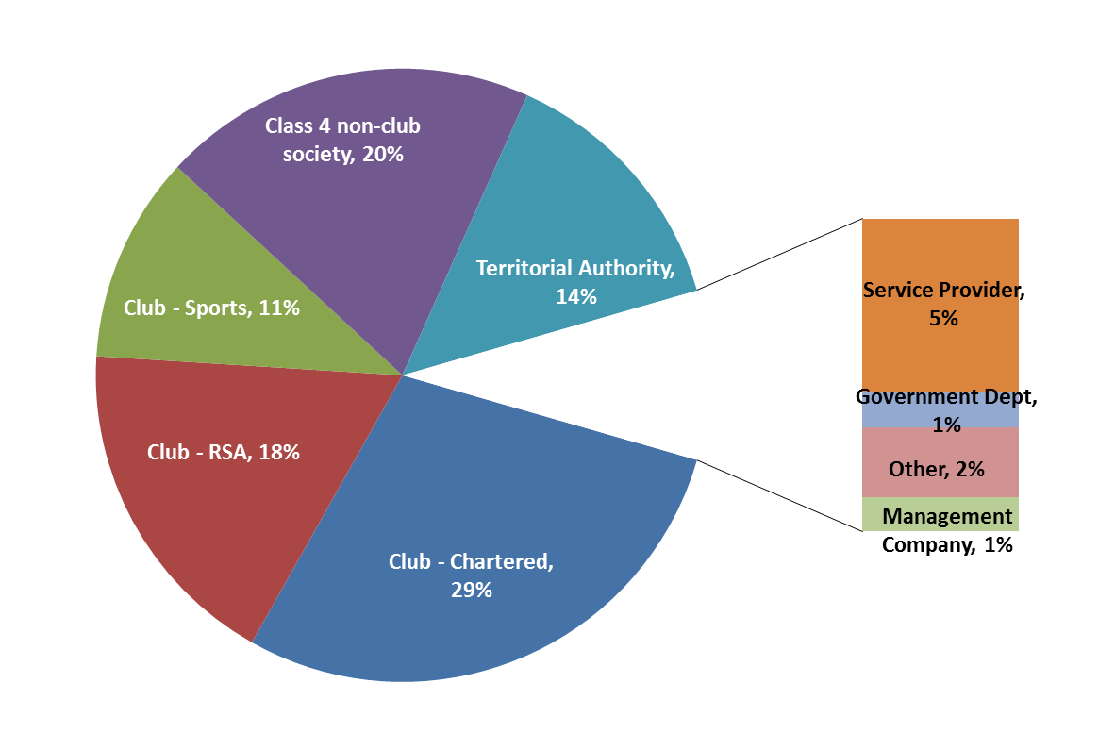
Figure 2 shows the percentages of respondents in each organisation type. Groups with the fewest respondents are displayed to one side for ease of reference.

“Other” was an answer option and thirteen responses were submitted. We allocated eight of these to one of the organisation types using the information provided (e.g. “Workingmen’s Club – allocated to Club-Chartered, Manufacturer – allocated to Service Provider). The remaining “Other” (2%) represents stakeholders that could not be categorised into a group.

Contacting Regulatory Services
Question 2: How do you prefer to contact DIA’s Regulatory Services Group, should you need to?
Figure 3: Preferred contact method.
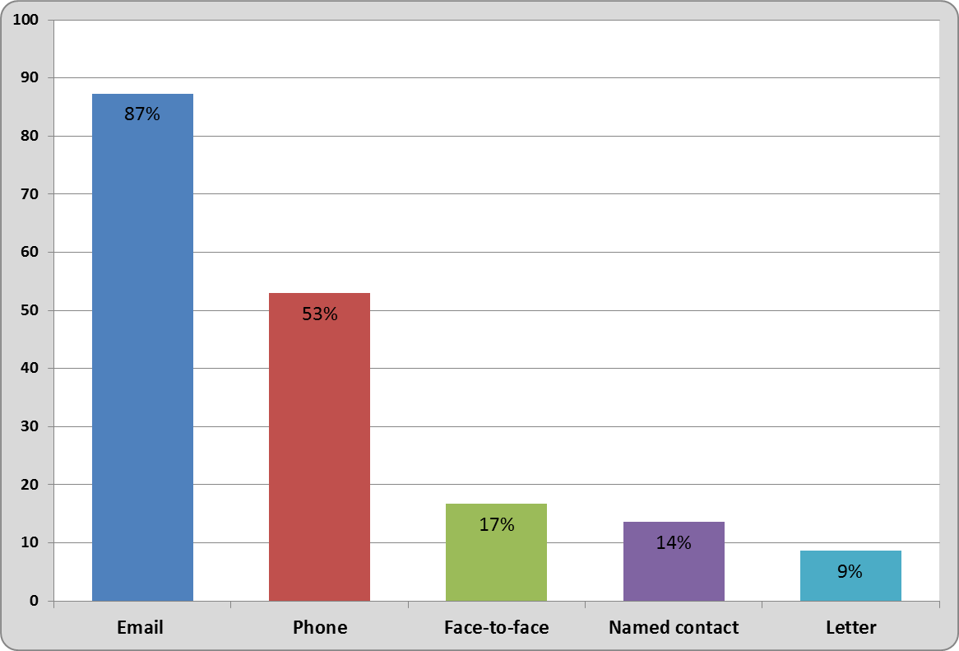Figure 3 shows the percentage of selections made for each of the contact options.

Respondents were able to choose more than one preference and a total of 396 selections were made by 221 respondents.

Email is the preferred method of contacting Internal Affairs by a considerable margin and this was consistent across all organisation types.

This follows a similar overall pattern to 2014, when the single choice question was “How have you mostly made contact with DIA?” Email (46%) and phone (37%) were the most popular choices.

Question 3: Have you contacted DIA over the past 12 months?
The majority of survey respondents had contacted the Department over the past 12 months (79%). The lowest contact groups were Territorial Authorities (55%) and Club-chartered (69%).

We asked respondents who answered yes to question three to provide information about their experiences of contacting us over the past 12 months.
Question 4: Tell us why you have contacted DIA over the past 12 months.
Figure 4: Reasons for contact.
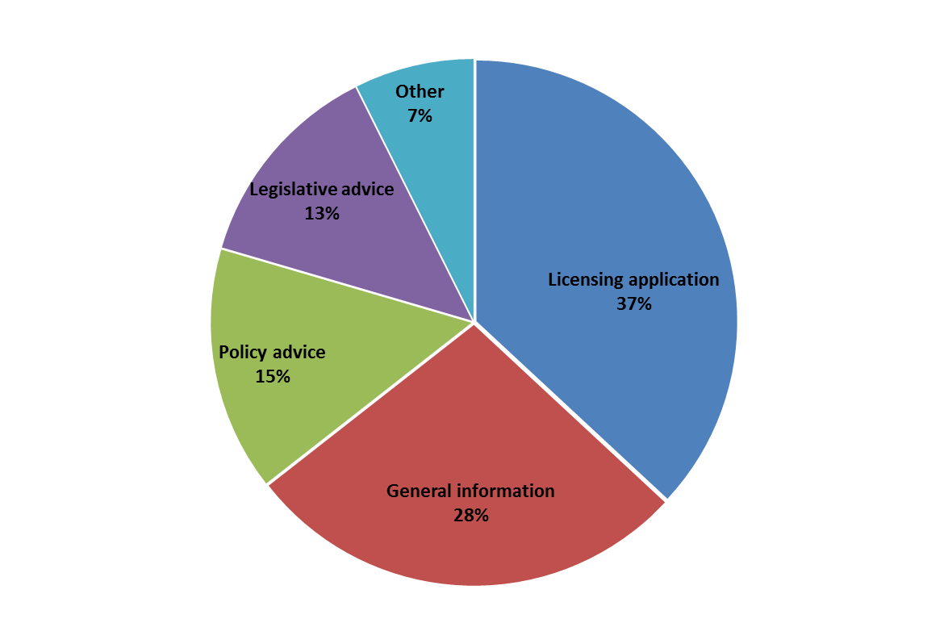
Figure 4 shows the percentages for each contact area.

Respondents were able choose more than one reason and 298 selections were made by 174 respondents. This indicates that the same individuals may contact us for a variety of reasons.

A significant number of contacts are linked to licensing applications (37%).
Compliance was a theme for a number of entries in the “other” category.

Class 4 non-club society contacts account for almost a third of the total contacts in our survey results (97/298). Selections were made in each of the above contact areas by this group, although licensing applications and general information were the most common reasons for getting in touch.

Respondents from Territorial Authorities also indicated a variety of reasons for contacting us, although most commonly for legislative and policy advice.
Licensing applications were the most popular reason for individuals to contact us over the past 12 months.

Professional Performance
The same respondents were directed to answer the next three questions about their experiences of contacting Regulatory Services for information.

Question 5: In general, how easy have you found it to obtain the information you need from us?
Question 6: In general, how would you rate the quality of information provided by DIA?
Question 7: In general, how would you rate the speed of our response to you?

These have been grouped together in our analysis to evaluate our professional performance. The questions use ratings scale from 1-5, with 1 being the lowest and 5 the highest.
For example:
1 – Very difficult
2 – Quite difficult
3 – Average
4 – Quite easy
5 – Very easy

Figure 5: Professional performance.
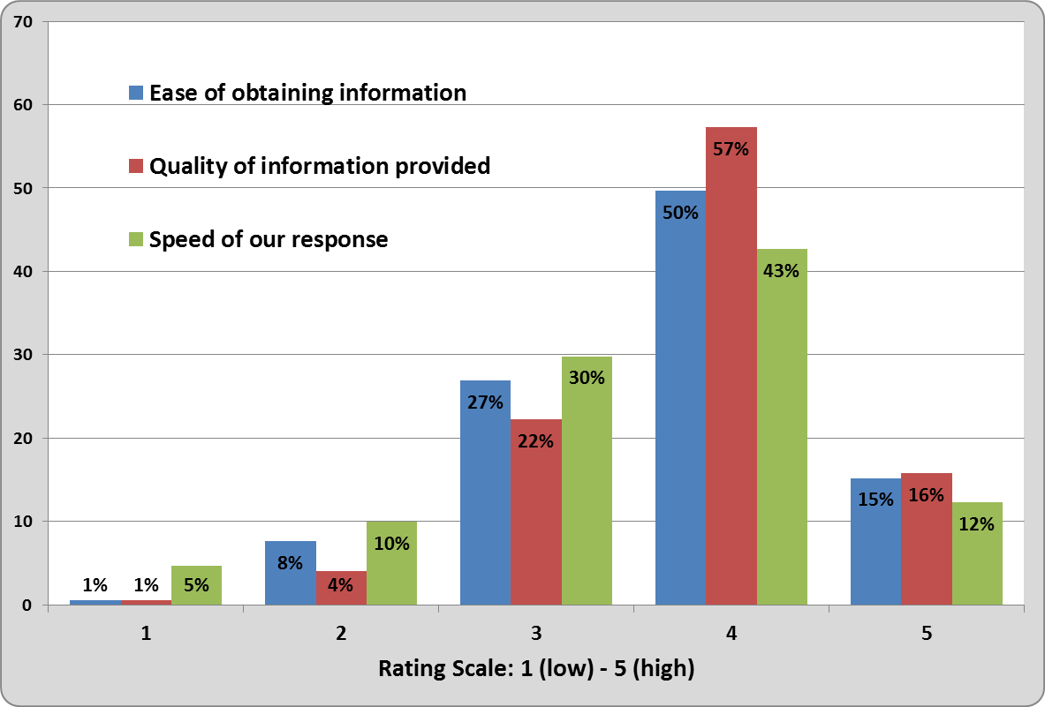
Figure 5 shows the percentages for selections for each of the three questions rating our professional performance.

Most ratings for our professional performance were high but there is room for improvement.

Ease of obtaining information
Almost two thirds of respondents rated obtaining information from us to be quite easy or very easy (65%).
A small number reported finding it quite difficult or very difficult (9%).
Just over a quarter of respondents rated their experience as average (27%).

Quality of information provided
Almost three quarters of respondents rated information to be of good or very good quality (73%).
A small number rated information as poor or very poor quality (5%)
Just over a fifth rated information quality as average (22%).

Speed of response
Just over half of respondents rated speed of response as quite fast or very fast (55%).
Several respondents rated response as quite slow or very slow (15%).
Over a quarter of respondents considered our response speed to be average (30%).

Generally, ratings across organisation types were consistent with individual ratings in all three areas.

These were new questions in 2015 and no direct comparison can be made with previous years.

Question 8: If you have any specific comments about your experience of contacting us please add them here.
A sample from the 35 comments received is provided (4/35):
“Found staff very approachable and helpful. Explained the issues in plain language.”

“I rang on a number of occasions left messages and had no reply.”

“Overall happy with response and answers given. However, there seem to be different interpretation [sic] of requirement when speaking to different offices (i.e. Auckland and Wellington).”

“Dealing with a specific individual has been of a good standard however using general email and ph below average.”

Providing information to the sector
We are interested in perceptions of how useful our current communications are in providing information to the sector. We asked respondents to indicate which they have used and rate how useful they have found each source.

Question 9: DIA provides general information to the sector in a number of ways. Please tell us how useful you have found these sources of information in the past 12 months.
Figure 6: Usefulness of information services.
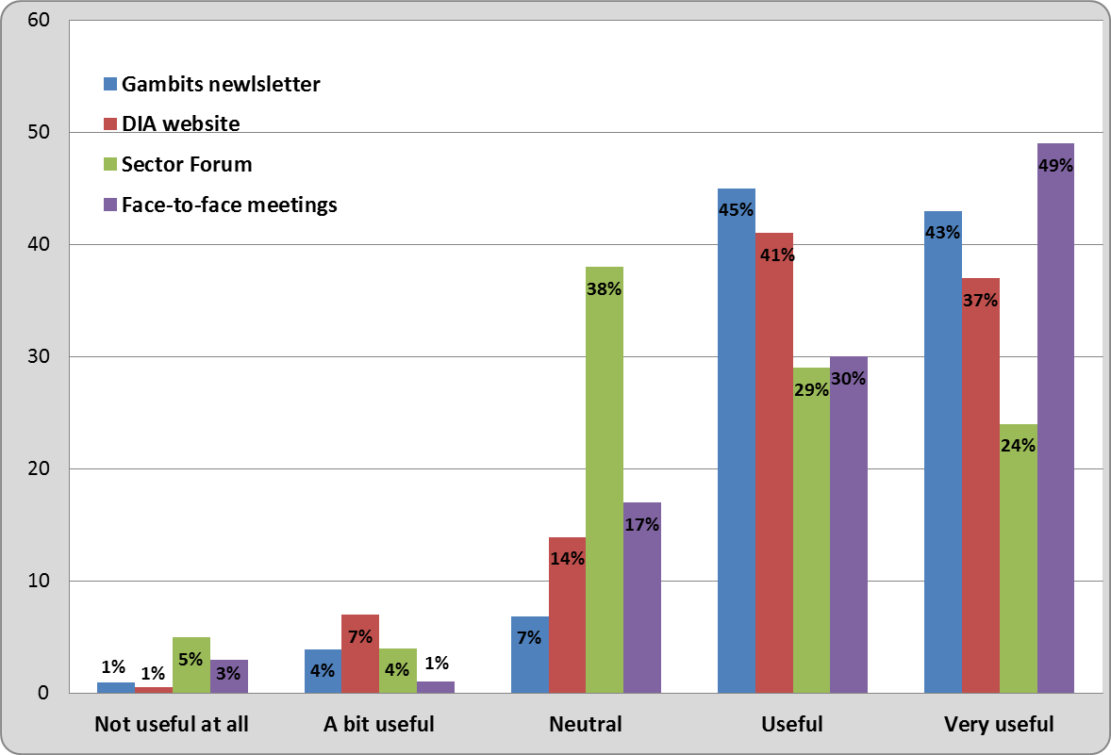
Figure 6 shows percentages for the ratings of each of the four sources we use to provide information to the sector.
Information we provide to the sector is viewed as useful or very useful. Gambits newsletter and DIA’s website are sources accessed by the majority of respondents.

Sector Forum
Sector Forums are regional meetings targeted at Class 4 non-club societies and key stakeholders for the purpose of engaging with the sector and exchanging information.
Forty per cent of our survey respondents indicated that they had not been involved in a sector forum.
Of the 112 respondents who rated Sector Forums as a source of information, just over 50 per cent indicated that they found them useful or very useful (53%). More than one third of ratings were neutral (38%) and the remainder rated the forums as a bit useful or not at all useful (9%).

Face to face
Almost 30 per cent of respondents had not been involved in a face to face meeting over the past 12 months (29%).

Of those that had been involved in a face to face meeting, the majority rated the experience as useful or very useful (79%).

Class 4 non-club societies are the group most likely to have been involved in a face to face meeting. Territorial Authorities and Chartered Clubs are least likely.

Gambits newsletter
More than 90 per cent of those responding (93%) to this question have used Gambits and this reinforces its value as an information source for the entire sector.

Of the 190 respondents who receive Gambits, most individuals rated it as useful or very useful (88%).
Gambits newsletter is a useful or very useful source of information and satisfaction with its frequency is high.

We asked a further specific question to find out about satisfaction with Gambits.
Question 10: How satisfied are you with the frequency of the Gambits newsletter?
Satisfaction ratings for its frequency were high, with 72 per cent of respondents being satisfied or very satisfied.
There were no notable differences in ratings across sectors.

The opportunity to provide specific comments was offered. A sample from the 21 comments received is provided (3/21):

“If it is an important issue we should be notified immediately rather than waiting for the scheduled Gambits release date.”

“Of late the publication is self-serving. The industry requires guidance not self-congratulatory rubbish.”

“Love the Gambits newsletter. Keeps me up to date and well informed with what’s going on.”

DIA Website
Almost all of the respondents to this question had used the website (97%) and of these, three quarters rated it as useful or very useful (78%).
Our website is widely used but comments suggest that information could be easier to find.

Question 11: The following information is available on the DIA website. Which have you referred to over the past 12 months?
Figure 7: Use of DIA website.
Answer choices: | Number of responses. | Percentage of respondents
Gambling forms | 129 | 62%
General information | 120 | 58%
Information about NZ gambling laws | 94 | 45%
Gambling fact sheets | 89 | 43%
Minimising harm, maximising benefit – DIA’s approach to compliance and enforcement | 65 | 31%
Information about problem gambling | 50 | 24%
News, press releases and consultation | 47 | 23%
Technical information about gaming | 37 | 18%
Self-assessment review | 33 | 16%
Pokies 101: a guide to how the system works | 26 | 13%
Funding for community groups | 23 | 11%
I used the website for something else (please specify) | 15 | 7%
I haven’t used the website | 14 | 7%
Leniency and cooperation policy | 5 | 2%
Figure 7 shows selections made, listed in order of popularity.

This question received responses from 208 individuals, who made a total of 747 selections which reinforces the importance of our website as an information source for the sector.

A number of respondents who “used the website for something else” specified using it to obtain statistical information.

Question 12: If you have any comments about using the DIA website please add them here.
A sample from the seventeen comments received is provided (4/17):
“There are no templates for Gaming Applications.”

“Pretty average website. Not exactly intuitive to navigate around but once the user knows where to look the information is generally there.”

“the SEARCH function could be improved.”

“It’s a great resource.”

Question 13: Does the content of information provided by DIA meet the needs of your organisation?
Almost all respondents selected either “Yes” (60%) or “Most of the time” (38%).

Question 14: If you have any comments about how the DIA communicates information to the gambling sector and/or the content of information provided please add them here.
A sample from the 15 comments received is provided (2/15):

“Needs to be all up to date. A few of the materials have not been updated with recent reg changes.”

“Appreciate the sector group meetings and other face to face meetings. The Department talks about trust and working cooperatively but the actions don’t match the words. It is simply rubbish to suggest that there is rampant and rising serious non-compliance – comments used to justify fees increases etc. Where is the evidence for this. There is a real “them” and “us” attitude.”

Approach to Regulation
We wanted to gauge sector perceptions of existing approaches in some key areas for us as a regulator. The following three rating questions received response from 207 individuals.

Question 15: To what extent do you agree that the sector is actively protecting gamblers and communities from gambling harm?
Figure 8: Gambling harm.
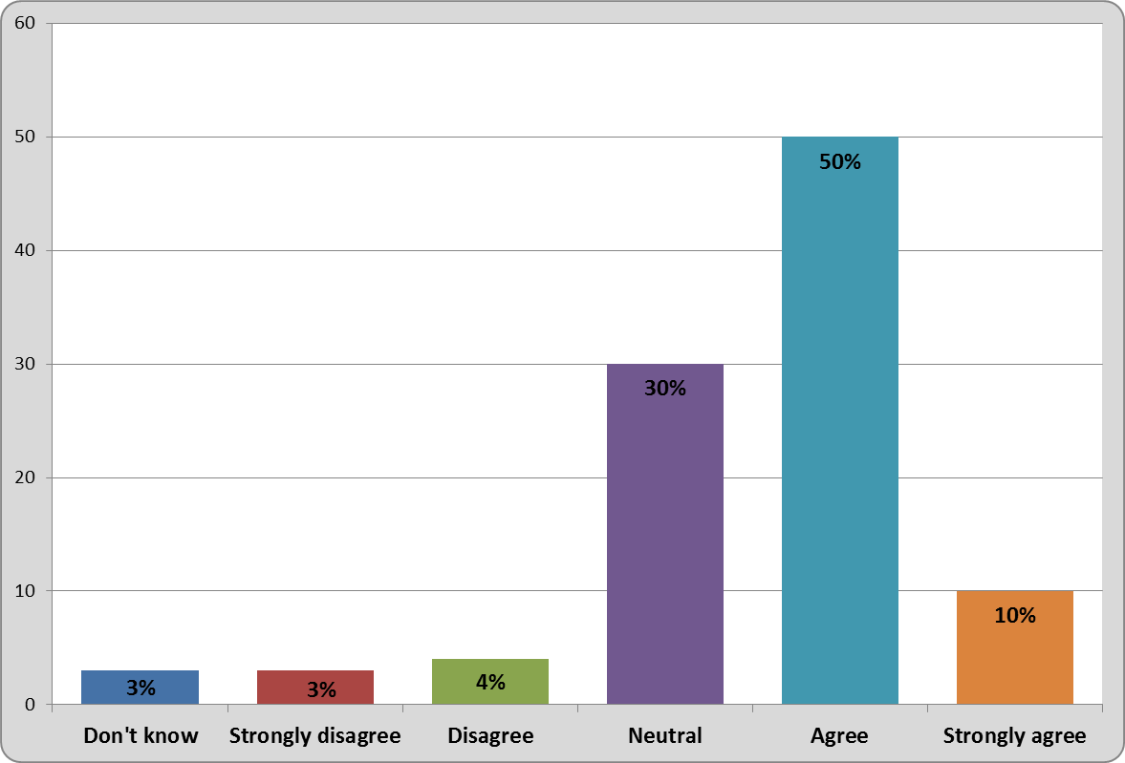
Figure 8 shows the percentage of selections for each rating option.

Well over half of individual respondents agree or strongly agree (60%).
Over a quarter are neutral (30%).
A small number of respondents disagree or strongly disagree (7%).

As a group, Class 4 non-club societies largely selected agree or strongly agree. Clubs (Chartered, RSA and Sports) are mainly positioned between neutral or agree. Respondents from Territorial Authorities and Service Provider groups are the most neutral.

Most respondents agree that the sector is actively protecting gamblers and communities from gambling harm.

The opportunity to provide specific comments was offered. A sample from 32 comments received is provided (3/32):
“The downloading of jackpot [sic] to gaming machines seems to be contrary to reducing harm to players.”

“The sector’s structure does not support behaviours from its participants to minimise harm. The incentives are not aligned as control of the sector is misplaced.”

“The current legislation in my opinion takes the responsibility for the problem off the problem gambler and places it on the venue manager. The venue manager has no idea of any one person [sic] current financial status yet is responsible for all problem gambling in their premises. This is unjust and unfair.”

Question 16: To what extent do you agree that the sector is working constructively with the regulator to achieve compliance?
Figure 9: Partnership.
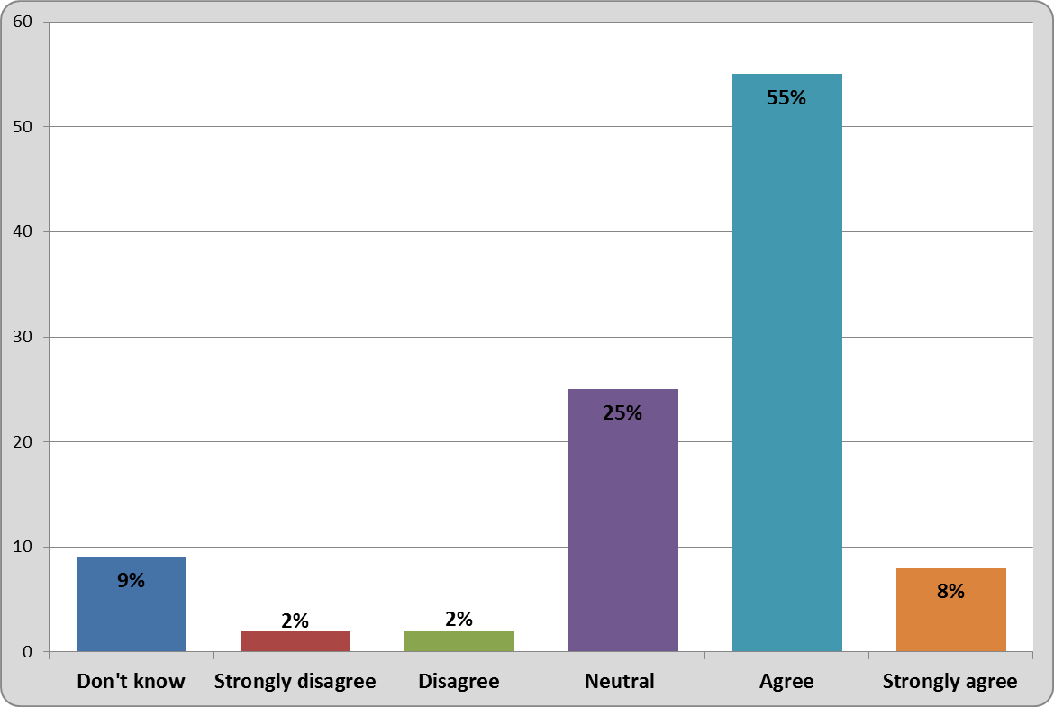
Figure 9 shows the percentage of selections for each rating option.

Well over half of individual respondents agree or strongly agree (63%).
A quarter of respondents are neutral (25%).
Just below ten per cent of respondents opted for “don’t know” (9%).
Broadly, there were no particular differences between organisation types, although as a group, Territorial Authorities were most neutral.

The opportunity to provide specific comments was offered. A sample from 16 comments received is provided (2/16):
“Some agencies work constructively with DIA, some don’t.”

“The sector wants to work with the regulator, but I’m not sure the regulator really wants to work with the sector.”

Question 17: To what extent do you agree that the sector maximises gambling returns to benefit community need?
Figure 10: Community benefit.
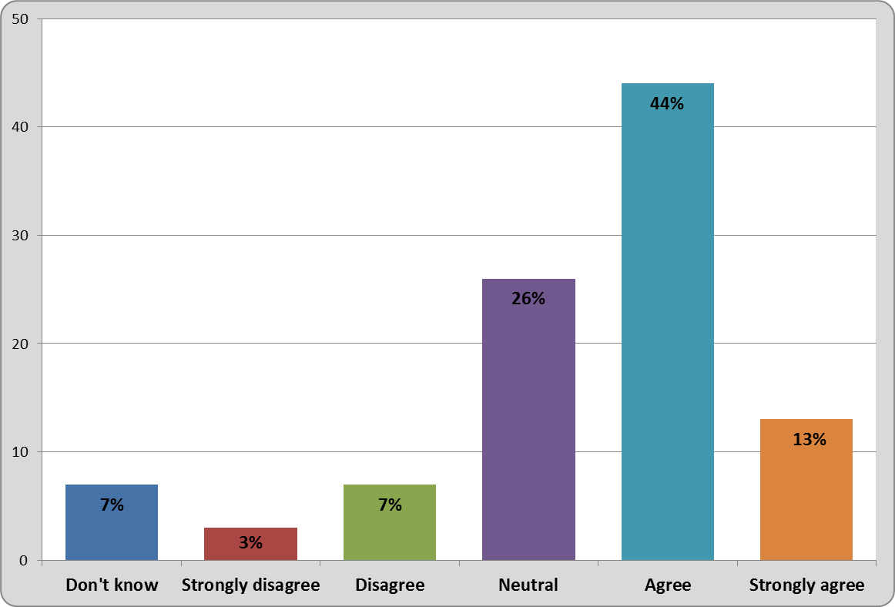Figure 10 shows the percentage of selections for each rating option.

Over half of individual respondents agree or strongly agree (57%).
A quarter of respondents provided neutral ratings (26%).
Ten percent disagree or strongly disagree (10%).

Broadly, there were no particular differences between organisation types, although as a group, Territorial Authorities were most neutral.

The opportunity to provide specific comments was offered. A sample from 28 comments received is provided (3/28):

“Horrendous licence and regulatory fees reduce funds available.”
“How can a sector with over 40 Licensed Trusts competing to secure venues provide an effective sector that maximises return and minimises harm.”

“There are some societies who channel the communities [sic] money to other areas. This is a judgement based on returns to AP. The re licensing of organisations not achieving minimum requirements has allowed this to happen.”

The Department’s approach to compliance is available in our document Minimising Harm – Maximising Benefit; The DIA’s approach to Compliance & Enforcement. The purpose of the following two questions was to find out how well our priorities are known by the sector.

Question 18: Please select statements from the list below that you agree describe DIA’s priorities in the gambling sector.
Figure 11: DIA’s priorities.
Answer choices. | Number of selections. | Percentage of respondents.
DIA is concerned about harm caused by problem gambling and the negative impact on families and communities. | 157 | 79%
DIA provides sufficient information and education relating to gambling harm-prevention and minimisation. | 134 | 68%
DIA works with the sector to ensure that maximum proceeds are returned to the community. | 94 | 47%
DIA focuses on enforcement. | 94 | 47%
The approaches that DIA takes to gambling regulation stop criminals from exploiting the sector. | 65 | 33%
DIA is successful in delivering tailored interventions to deal with issues | 38 | 19%
None of these statements describe DIA’s priorities in the gambling sector. | 7 | 3%
Figure 11 shows the number of selections from 198 respondents, listed in order from most to least (Total 589).

A high percentage of respondents agree that Internal Affairs is concerned about harm (79%) and this was consistent across all respondent groups.

Over two thirds of individuals agree that Internal Affairs provides sufficient information relating to gambling harm (68%).
As a group, Class 4 non-club societies made fewer selections for this statement (51%).

Almost half of respondents selected one of the Department’s priorities as focusing on enforcement (47%).
As a group, Club-sports had the highest proportion of selections for this statement (53%).
“None of these” was selected by a small number of respondents (3%).
Our priorities connected to gambling harm are well recognised by the sector.

Question 19: Please select statements from the list below that you agree describe the way DIA works with the sector.
Figure 12: DIA’s approach.
Answer choices | Number of selections. | Percentage of respondents
DIA provides the tools and guidance necessary to support compliance. | 133 | 67%
DIA is clear and open about its regulatory approach. | 130 | 66%
DIA supports the gambling industry to enable a safe gambling sector. | 104 | 53%
DIA provides opportunities for input to policy development or decisions. | 81 | 41%
DIA takes time to understand our perspective. | 61 | 31%
DIA engages with you in making its decisions. | 54 | 27%
DIA understands the business environment in which we work. | 53 | 27%
None of these statements describe DIA’s approach to working with the sector. | 9 | 5%
Figure 12 shows the number of selections from 198 respondents, listed in order from most to least (Total 625).

Strong agreement with the first two statements is indicated, with approximately two thirds of respondents making selections (67% and 66% respectively).
As a group, Class 4 non-club societies made fewer selections for both of these statements (56% and 54%).
Approximately three quarters of clubs selected these statements and this was consistent across all three club types (average 76% and average 73%).

Approximately a quarter of respondents agree that Internal Affairs understands the business environment (27%).
As a group, Class 4 non-club societies made fewer selections for this statement (12%)
As a group, Club – RSA respondents were more likely to agree (44%).
Respondents from Territorial Authorities were the group least likely to agree that Internal Affairs takes time to understand their perspective (12%).

“None of these” was selected by a small number of respondents (5%).
Many respondents agree that DIA provides tools and guidance to support compliance and that we are clear and open in our regulatory approach. Other approaches to working with the sector are currently less well developed.

Question 20: In general DIA’s decisions are clearly communicated to my organisation.
Figure 13: DIA’s decisions
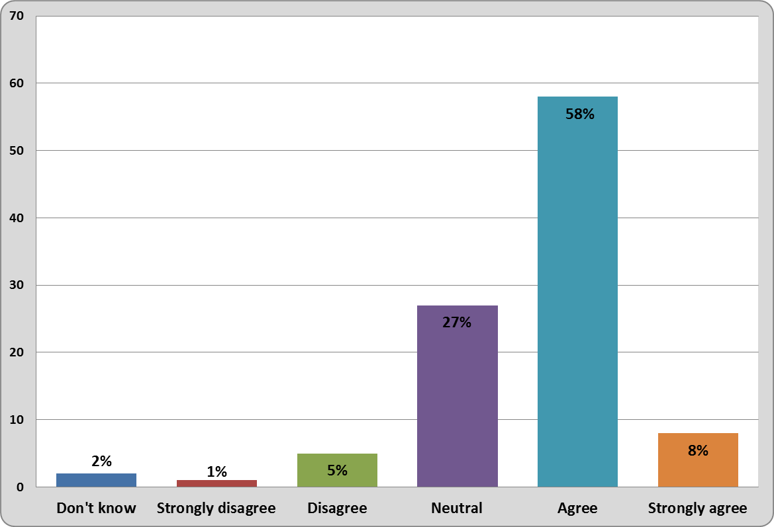
Figure 13 shows the percentage of selections for each rating option.

Almost two thirds of individual respondents agree or strongly agree (66%).
Just over a quarter are neutral (27%).

There are no particular differences across organisation types.

The opportunity to provide specific comments was offered. A sample from 14 comments received is provided (2/14):
“The DIA need to take an inward look at itself as there is such a variation in the way individuals work with trusts. This leads to confusion.”

“In all my dealings with DIA staff I have had excellent service.”

Ethnic Diversity
Question 21: Tell us in what ways ethnic diversity is evident in your organisation – e.g. in your governance structure; staffing; harm minimisation practices, etc.
We are interested in collecting demographic, ethnicity and iwi affiliation information about those engaged in the sector to help improve our strategy and programmes.

This question was optional and offered a free text response. We received 100 answers.
We were able to group comments according to themes, although some comments had more than one theme.
The main themes were:
- Staff membership
- Governance
- Generally in evidence
- Ethnic diversity vs equal opportunity
Approximately 21 respondents commented that ethnic diversity is generally evident in their organisation, through having diverse and different cultural backgrounds across all areas of the operation, and ranging from membership to staffing and governance. An additional 23 respondents specifically mentioned diversity in staffing and/or governance. For example, one organisation said they have a bicultural strategy for staffing and one includes cultural awareness in staff training.
As further examples, one organisation stated that they have ethnic diversity in their governance structure and members, and another commented that ethnic diversity in staffing and governance is encouraged.
Nineteen respondents provided comments along the lines that ethnic diversity is not an issue because they treat all people the same and they are equal opportunity employers.
Sixteen respondents commented that ethnic diversity isn’t evident in their organisation, generally through its small size, the lack of diversity in their community or it wasn’t something they have considered.
A further sixteen respondents either didn’t know, or replied that the question was not applicable.
Eight respondents commented that ethnic diversity was reflected in their harm minimisation policies.

Final Comments
Question 22: Please tell us about any areas of interest or concern that you feel are currently overlooked but you would like DIA to consider focusing on in future.
This final question was optional, requiring a free text response. Sixty-six respondents provided a comment.

There are several common themes that the comments can be grouped under. The themes with the most comments were:
- Communication
- Processes
- Enforcement
- Costs
In relation to communication, respondents suggested better liaison, more proactive contact by the Department, more support for smaller organisations and more use of the knowledge and experience within the sector.
In relation to processes, respondents were looking for faster turnaround of licensing applications, forms that are easier to complete, less paper work and more use of digital technology.
The comments made under the theme of ‘enforcement’ were urging more consequences for non-compliance, and a need to be tougher on societies. On the other hand, inadvertent errors and minor lapses should be more easily dealt with.
Respondents raised costs as another common theme, citing high compliance costs and unbalanced costs between large and small organisations as issues that Internal Affairs could consider for the future.
Additional comments were received around:
- Suggestions for improvements to legislation and regulations
- Suggestions for improving the grants distribution system and
- Suggestions for ensuring sustainability of the C4 sector, including changing the structure.

Conclusion
This annual survey provides the Department of Internal Affairs with useful information about how the gambling regulator is perceived by others in the Class 4 gambling sector.
The responses help guide our focus and inform us about areas that may need tweaking or improving.
Recently we have been making changes to how we engage with the sector – for example sharing our strategic direction with society Boards at meetings which we hope will become a regular feature of the calendar. We have also developed a new vision for the Class 4 sector and we are hoping future surveys will help us measure the impact of these and other developments.
This year we are particularly pleased to note that:
- Most ratings for our professional performance are high
- Our priorities connected to gambling harm are well recognised by the sector
- Many respondents agree that DIA provides tools and guidance to support compliance and that we are clear and open in our regulatory approach.
- Satisfaction with our Gambits newsletter is very high, and
- Our website is widely used.

In 2016, we are looking forward to building on our vision and objectives, which put a transparent and trusted sector at the heart of our approach.
- Survey questions
A copy of all survey questions is available at: https://www.dia.govt.nz/diawebsite.nsf/wpg_URL/Resource-material-Our-Research-and-Reports-Index?OpenDocument#five

Gambling Act 2003

