Service Delivery and Operations
Customer Experience Survey
2018/19

Analytics and Reporting / Customer Design and Uptake
Service Delivery and Operations

Acknowledgements

The Department of Internal Affairs acknowledges the team at Research New Zealand for their analysis of the data.

Authors:

Matt Disney - Analytics and Reporting, Operations

Jehan Perera – Customer Design and Uptake – Services and Access

Introduction

This report provides a summary of key findings from the 2018/19 Service Delivery and Operations Customer Experience Survey.

Service Delivery and Operations (SDO) provides a variety of services to the public including passports, community advisory and funding services, birth, death, marriage, civil union, and name change, authentications, citizenship, charities registration, and identity verification services.

In this survey we seek to understand how the public rates our service, how they interact with SDO and what we can do to improve our service.

The 2018/19 survey is the seventh year this survey has run to monitor public satisfaction over time, and to monitor responses to changes in our service delivery. In April 2019 a new digital services module was introduced to the survey. Detailed findings from this module are included in this report.

Key Findings

Customer satisfaction with the services that SDO deliver remains high. Customers continue to have high expectations of the service they will receive and comments show us that customer expectations of our services continue to evolve. We are well underway with our customer centred service transformation which will substantially shift the way our services are delivered, in line with customer expectations. Results from the new digital services module of this survey show a strong preference for accessing our services online, where they are available.

Overall Satisfaction

The overall satisfaction figure for the entirety of SDO has remained high. Most business groups show a small increase or decrease; however these are within the margin of error. The exception is Births, Deaths and Marriages, which has had a significant recovery following the drop last year. Charities Services shows a similar recovery after a drop in 2017/18; however this is still just inside the margin of error so we cannot say for sure there has been a change.

Most channels show small variations within the margin of error year on year with the exception of counter/face to face which shows a statistically significant decline from 2017/18 to 2018/19. Phone also shows a statistically significant decline when comparing the results over the last three years. Customer commentary suggests long waiting times and/or the lack of a queue hold/call-back feature as reasons for falling satisfaction with phone services. Commentary relating to a lack of satisfaction with counter/face-to-face services is mainly related to convenience issues (opening hours, parking).

The majority of customers continue to have high expectations of the level of service they will receive and felt that the resulting service exceeded their expectations.

Examples of positive feedback provided by customers:

I applied for citizenship and passport by descent. My application was handled at the Wellington branch. My mother, whom was born and raised in New Zealand, was able to lodge the application on my behalf as she was my sponsoring parent for the application. Staff were friendly, competent and very prompt in receiving and processing my application. Various e-mail and telephone communication for further details pertaining to my application was prompt and handled very competently. The good service from the staff significantly helped make the process very low stress.
Staff were very efficient and very helpful, they made me and my partner feel very relaxed throughout the whole process.
Always happy to assist. I have had meetings and asked for assistance in many other matters. The staff in [location] are professional and very helpful. Our marae successfully obtained funding in 2015 for our wharekai, after 50 years without one, and we opened it in 2016. I highly recommend our [location] officers [name and name]. They are an asset to the DIA, and have been making greater efforts to work with our community.

Key Service Measures

SDO customers continue to rate key service measure highly. All of these measures have had an increase over last year, with most being statistically significant. The survey does not give customers an opportunity to comment on why they have given a particular rating, but the majority of customers do say that these service measures are very important (on a scale of 1 to 5, with 5 being very important) when giving a rating for overall quality of service received.

Ease of doing business with DIA

Overall, 86 percent of SDO customers say it is easy to do business with us. This number has remained consistent for the last few years. Most of the business units that make up SDO show small variations within the margin of error.

Charities Services shows a strong improvement in this measure over last years’ results. Charities Services implemented a new operating model, which focuses on a modern, responsive, risk based approach. As a result, many processes have become more streamlined. They have also had a focus on reducing the timeframes for key decisions.

Community Operations has had a significant drop in this measure after an equally significant rise last year. The results suggest that the improvements last year have now become the expectation, but will be monitored more closely for greater understanding. Further analysis into ease of doing business results, based on the size of organisations, length of time organisations have been operating and the types of funding these organisations access will be carried out to better understand how we can improve the service experience for different types of organisations.

For the first time, we have explored how customers rate ease of doing business by service channel. Customers rate interactions online and via phone as slightly easier than interactions via post or in person at our counter sites.

Trust and Confidence

SDO customers continue to report high trust and confidence in the Department of Internal affairs. The slightly lower scores for Charities Services and Community Operations Services reflect the more complex regulatory nature of these areas of the business.

Service Improvements

30% (778/2596) of customers felt that SDO could make some form of improvement to our service. This is a drop of over 10% from 2017/18. Some of this drop was due to an increase in the amount of respondents who answered ‘don’t know’, or refused to answer the question.

Of those who did respond to this question, the largest group was again those who suggested we make improvements to our website (e.g. more user friendly, offer more services online). Other common suggestions were the ability for customers to have more visibility of the status their application/service request and that we should know more about our customers – they feel we should not have to ask again for information we have asked for previously.

Examples of the types of comments received from customers regarding improvement are:

It would be great if it pre-populated your information based on what you already know about me, i.e. my passport number. However if this is a safety feature to reduce fraud then by all means put barriers up!

Probably work on their website so it flows better and also, I couldn't access it on my phone. It didn't work on my phone and I had to use the computer, which was a little bit annoying for me. I didn't always have access to a computer.

Would be helpful if you could check status of application online.

Introduction to the digital module
In April 2019 a new digital services module was introduced to the survey — the questions of this module aimed to understand recent customer’s use and attitudes toward SDO’s digital services. This digital module was only included during the April -June 2019 quarter and only asked to a subsample of customers that completed a service that is available to online (n=466).

As this module only covered the last quarter of the year, some results contained within may differ slightly from overall results detailed elsewhere in this report.

Awareness of online services, online attempts and online success rate
The 466 customers that recently completed a SDO service that could be completed online were asked their awareness and use of the online channel.
- The majority (84%) of customers were aware they could complete their service online.
- Almost all of those who were aware, attempted to complete their service online. (93% of those aware).
- Over 9 out of 10 of those who attempted to complete their application online were successful.
- Only 13% of the total sample did not complete their service online. The attitudes of the group that did not apply online will be explored in subsequent sections.
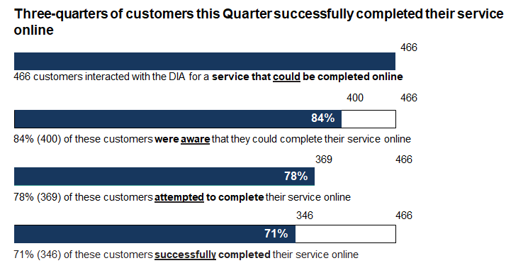

Satisfaction with recent online experience
93% of customers were satisfied with their recent online experience – 76% of these were very satisfied. Satisfaction with the online experience was slightly lower than customers who completed their service via telephone or by going to a physical branch.
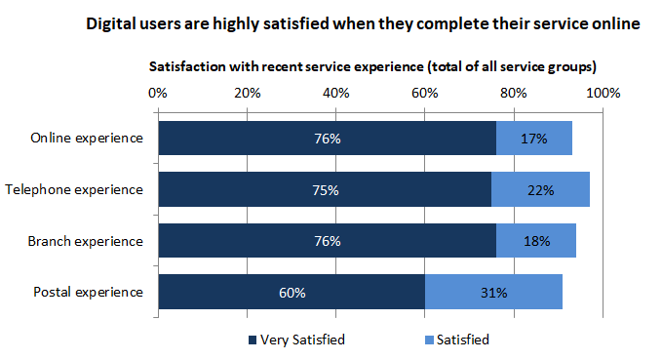
Out of SDO’s services that can be completed online – Identity Services had the highest satisfaction score with around 93% stating they were satisfied or very satisfied with their online experience. Identity services consist of Passports, Citizenships and Births, Deaths and Marriages.
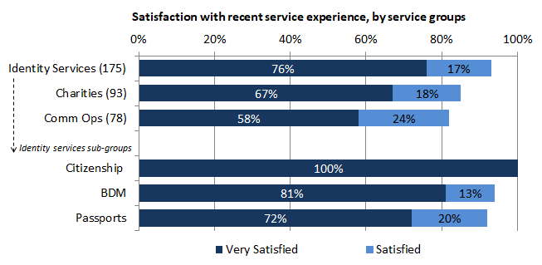

Digital customers’ needs
When deciding how to apply online, customers reported the most important factor was the clarity of the instructions. This was followed closely in importance by ‘It would be easy to do’ and that their 'privacy would be protected’. At least 83% of online customers were satisfied or very satisfied with all the following statements: ‘Instructions were clear’, ‘it was easy to do’, ‘my privacy was protected’, ‘I did it when I wanted to’ and ‘it took little time’.
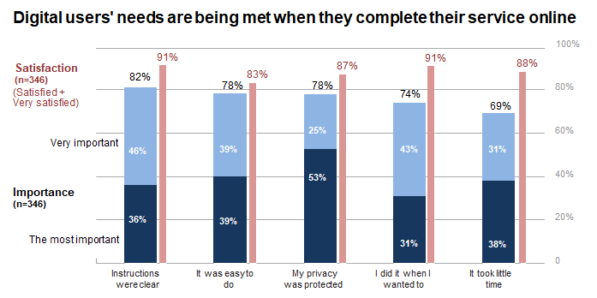
Perspectives of non-digital customers
29% of customers reported that they didn’t complete their service online. The most common reason given was because they were not aware there was an online option (12%).
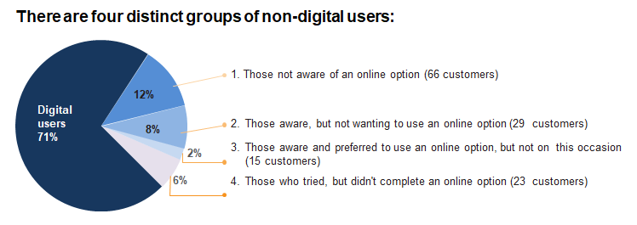
Other reasons given for not completing their service online:
- 8% were aware but preferred not to use an online option. The main reasons provided were that customers preferred to talk to someone (32%) or they didn’t trust the security of online applications (29%).
- 6% tried but didn’t complete their service online. The main reasons provided for not completing their applications online was that they couldn’t because they had to provide additional information such as documents or photos.
- 2% preferred to go online by didn’t because of practical issues like not being eligible.

Next Steps

SDO is working to transform our system of service delivery. Findings from this research will continue to help us understand our customers’ needs and enable us to see the effect of service changes on our customers. A programme of continuous improvement is being undertaken based on customer and staff experience.

Improving our web and digital services is a strong focus for SDO. Analysis from the survey, particularly of customer comments, will help direct this. Projects that have been either during the course of the 2018-19 survey or since its completion are:
- Improvements to the BDM online service – customers can now order all types on non-historical certificates/records online.
- Successful pilot of our citizenship by grant online system and more recently the full rollout of the ability for customers to apply for citizenship by grant online.
- Citizenship by grant online (for individual adult applicants) is the first service available in our Customer Centered Management Solution (CCMS). CCMS is a new application that will provide a single view of customer that will eventually replace the multiple current systems that are in use. CCMS will allow us to put the customer at the centre of our service delivery, record all interactions and transactions in one place and over time create better self-service for customers.
- Future additions to CCMS are to be the ability for more customers to be able to apply for citizenship by grant online (family groups and children) and first time child passport applicants (currently the only type of applicants unable to apply for passports online).

The SDO Customer Experience Survey is being run again in 2019/20 with results expected to be published late January 2021.

Methodology

The 2018/19 survey was run continuously during 2018/19. Recent customers were asked to participate via a telephone or online survey. 2596 customers completed the survey. The margin of error is between 3.9% and 4.8% for each business group. The margin of error across the total of SDO is 3.0%.

