**AML/CFT**

**Anti-money laundering and countering financing of terrorism**

# Customer Due Diligence – Clubs and societies

## *This fact sheet is to be read in conjunction with the beneficial ownership guideline.*

Clubs and societies can take many forms and may vary in size and complexity. Examples include sporting clubs, social clubs, or other relatively informal clubs and interest groups, such as a motorcycle enthusiasts’ club.

The type of entity the club or society is will determine the customer due diligence (CDD) that is undertaken.  A club or society may be one of a variety of types of entity, for example a trust. Clubs and societies can be incorporated as protection for members, but this is not a legal requirement.

## Introduction

Section 11 of the Anti-Money Laundering and Countering Financing of Terrorism Act 2009 (the Act) requires you to conduct CDD on:

1. a customer;
2. any beneficial owner of a customer;
3. any person acting on behalf of a customer.

## Customer identification

### a) On the club or society.

### The information required for identification is:[1]

* name of club or society (legal name if different),
* legal status and purpose, and
* principal or registered office address.

You are required to obtain information on the nature and purpose of the business relationship you will have with the customer.[2] If you are conducting enhanced CDD, you will also be required to obtain information on the source of funds or wealth of the customer.

### b) On the beneficial owners of the club or society:

A beneficial owner is an individual who satisfies any one element, or any combination of the three elements, of the definition of a beneficial owner in section 5 of the Act. You must identify all beneficial owners. The information required to identify the beneficial owners is:

* name,
* date of birth,
* address, and
* any information prescribed by regulations. At the time of publication of this guidance no additional information had been prescribed for clubs and societies.

For clubs and societies, the beneficial owners may include:

* the president, secretary and treasurer,
* current committee or management team, and
* other members with effective control of the club or society.

Beneficial owners of clubs and societies often change. Ongoing CDD requires you to update information on beneficial owners when changes occur. The timing for customer reviews as part of ongoing CDD will be determined by your risk assessment for the customer type.

### c) On the persons acting on behalf of the club or society:

Acting on behalf of the customer is when a person is authorised to carry out transactions or other activities on behalf of the customer. For clubs or societies, this includes persons who have authority to act on behalf of the organisation, for example the treasurer, or other persons able to transact on an account.

The information required to identify the persons acting on behalf of the club or society is:

* full name,
* date of birth,
* address,
* the relationship to the customer,
* company identifier or registration number (if applicable), and
* any additional information prescribed by regulations. At the time of publication no additional information had been prescribed.

The person acting on behalf of the club or society must be a properly authorised representative.

**Money laundering or financing of terrorism risks**

Examination of the club or society’s purpose and size may reveal information that changes its risk profile. If the organisation has a social or local community focus, such as a youth sports group, you may decide its risk is different to those that have off-shore links. Clubs and societies with a national profile will have more information available for you to consider. A further risk factor to consider is whether the club or society is cash-intensive and able to be used for the placement of illicit earnings.

## Verification

The club or society structure and arrangements should be verified using documents, data or information issued by a reliable and independent source. The provision of the constitution, charter or rules will also assist in establishing the objects of the club or society and the type of individuals that benefit from the organisation.

Smaller clubs and societies may not have a public presence or social footprint but information sources, such as bank statements, may be used as supporting evidence for verification purposes. Governing body websites, such as a national sporting federation, may provide additional information.

An individual’s authority to act on behalf of a club or society should be verified. This can be established by contacting the club or society.

You are required to take reasonable steps to verify the identity information obtained. The information gathered will assist you with ongoing account monitoring.

Updated July 2019

**Version History**

|  |  |
| --- | --- |
| April 2013 | Original version |
| July 2019 | Removal of the word “or” in paragraph (b) under “Introduction” to align with Section 11 of the Act. |

*Disclaimer: This fact sheet is intended to be read in conjunction with the AML/CFT guidelines from the AML/CFT supervisors. While reasonable measures have been taken to ensure the quality and accuracy of the information contained in this fact sheet, it does not replace information contained in the Act or related provisions and regulations. This fact sheet is for general information only and is not a substitute for independent, professional legal advice.*

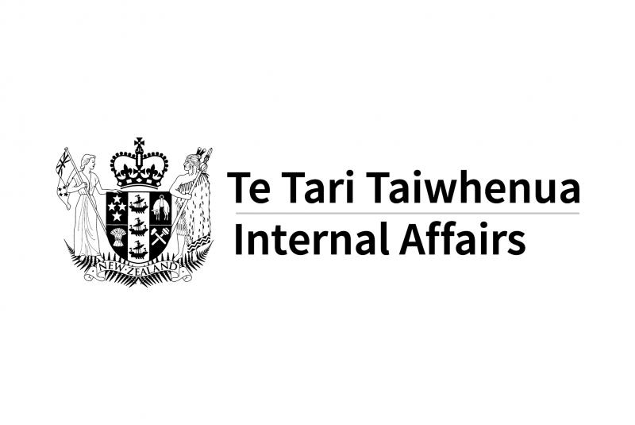

1. The appropriate level of CDD required will depend on the circumstances.
2. Section 17 of the Act.