**AML/CFT**

**Anti-money laundering and countering financing of terrorism**

# Customer Due Diligence – Co-operatives

## *This fact sheet is to be read in conjunction with the beneficial ownership guideline.*

A co-operative is a form of business organisation that is owned and controlled by its shareholders or members, and run for their mutual benefit.

This fact sheet may also be useful when considering customers who are mutual organisations or friendly societies.

## Introduction

Section 11 of the Anti-Money Laundering and Countering Financing of Terrorism Act 2009 (the Act) requires you to conduct customer due diligence (CDD) on:

1. a customer;
2. any beneficial owner of a customer;
3. any person acting on behalf of a customer.

## Customer Identification

### a) On the co-operative.

### The information required to identify the co-operative is:[1]

* full name,
* business address,
* registered number (if applicable), and
* any additional information as prescribed by regulations. At the time of publication no additional information had been prescribed.

You are required to obtain information on the nature and purpose of the business relationship you will have with the co-operative.[2] If you are conducting enhanced CDD, you will also be required to obtain information on the source of funds or wealth of the customer.

### b) On the beneficial owners of the co-operative:

A beneficial owner is an individual who satisfies any one element, or any combination of the three elements, of the definition of a beneficial owner in section 5 of the Act. You must identify all beneficial owners.

The information required to identify the beneficial owners is:

* full name,
* date of birth,
* address, and
* any information prescribed by regulations. At the time of publication of this guidance no additional information had been prescribed for co-operatives.

For co-operatives, the beneficial owners may include:

* members of the co-operative,
* senior management, and
* any other person with effective control.

### c) On the persons acting on behalf of the co-operative:

Acting on behalf of the co-operative is when a person is authorised to carry out transactions or other activities on behalf of the customer. For co-operatives, this includes persons who have authority to act on behalf of the organisation or persons able to transact on an account.

The information required to identify the persons acting on behalf of the co-operative is:

* full name,
* date of birth,
* address,
* the relationship to the customer,
* company identifier or registration number (if applicable), and
* any additional information prescribed by regulations. At the time of publication no additional information had been prescribed.

The person acting on behalf of the co-operative must be a properly authorised representative.

**Money laundering or financing of terrorism risks**

When assessing the ML/FT risk that the co-operative customer poses to your business you may consider the size, structure, reputation within industry and whether it is local, national and/or international. Under a risk-based approach each customer is assessed on a case by case basis.

## Verification

The co-operative structure should be verified using documents, data or information issued by a reliable and independent source. This may require the provision of a constitution, statutory declarations for directors of companies that are co-operatives, deeds of appointment or amendment, structure chart and financial statements. An internet search of the co-operative name will reveal information from directory and other websites.

If you have decided that the available co-operative information is insufficient, you should consider what further steps you may need to take and record why you have taken those steps. This may also influence the reasonable steps you choose to take in establishing the beneficial ownership information.

You are required to take reasonable steps to verify the identity information you have obtained. The information gathered will assist you with ongoing account monitoring.

Updated July 2019

**Version History**

|  |  |
| --- | --- |
| April 2013 | Original version |
| July 2019 | Removal of the word “or” in paragraph (b) under “Introduction” to align with Section 11 of the Act. |

*Disclaimer: This fact sheet is intended to be read in conjunction with the AML/CFT guidelines from the AML/CFT supervisors. While reasonable measures have been taken to ensure the quality and accuracy of the information contained in this fact sheet, it does not replace information contained in the Act or related provisions and regulations. This fact sheet is for general information only and is not a substitute for independent, professional legal advice.*



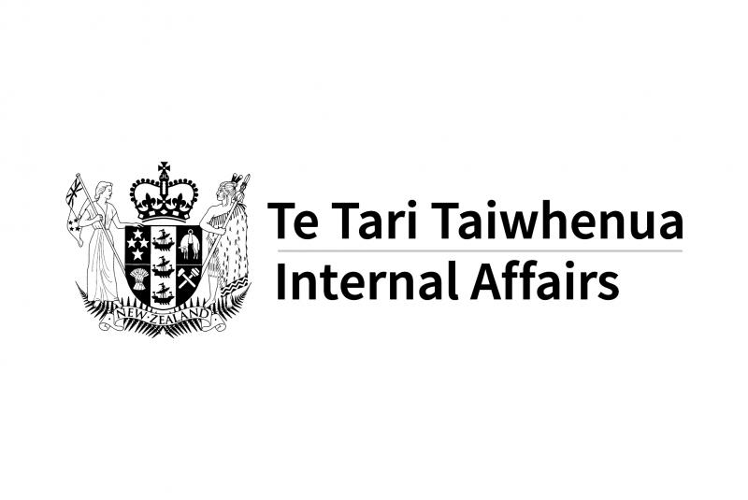 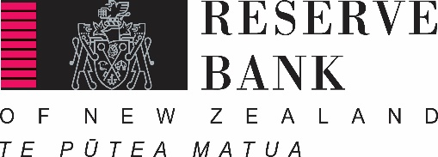

1. The appropriate level of CDD required will depend on the circumstances.
2. Section 17 of the Act.