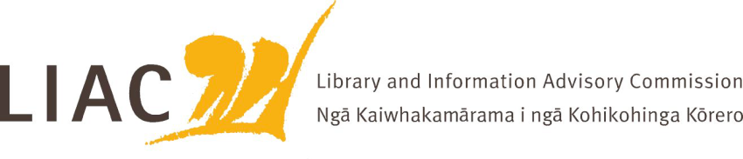

**Summary of meeting – 15 April 2024**

The April meeting was held remotely.

All Commissioners were present.

1. **Te Pouhuaki National Librarian update**

* The National Emergency Management Agency (NEMA) has noted the resilience and importance of APNK during severe weather events.
* Baseline reductions required to meet government savings targets, proposal re Index New Zealand
* Functional design update
* Exploration of partnerships with national libraries and national archives of Australia, Canada and United States to share expertise and work on projects of mutual interest, including involvement of first nations peoples (where NLNZ expertise is particularly sought) and uses of AI, for example for indexing.

1. **Learning and Literacy**

* Update on learning and literacy strategy, in particular a number of delivery initiatives that are being trialled. For example, offer of standing orders for smaller schools has been adopted by 200 schools. Working more closely with Ministry of Education on literacy initiatives. Research projects underway with NZCER and SLANZA. Content development includes addition of more national stories to support the history curriculum.

1. **Professional development**

* Archives Council representatives joined LIAC to discuss future of professional education relating to information studies, libraries and archives. Opportunities for a wider discussion and strategic view following proposed reductions to VUW programmes last year. Meeting to be organised with VUW in first instance.

1. **Commission activities**

* LIAC has prepared a briefing document for the incoming Minister of Internal Affairs. A copy is available on the LIAC website.
* Commissioners reviewed their Scope of Work and propose the following topics as priorities for 2024:
  + NLNZ direction - digitisation programme, Te Ara Tahi programme
  + Digital inclusion and information literacy – APNK, wider digital inclusion landscape
  + Information access – open access issues, new legislative directions including copyright and public records acts.
  + Sector awareness and engagement – workforce capacity and development, public library trends, relationship building with library associations.
* LIAC will prepare a submission on FENZ levies, especially their impact on cultural heritage institutions.
* LIAC will refresh and strengthen its Mātauranga Māori position statement.
* LIAC will continue discussions relating to the future sustainability of NZLII.
* Commissioners thanked and farewelled Paula Eskett. The process to recruit a new Commissioner will begin shortly.