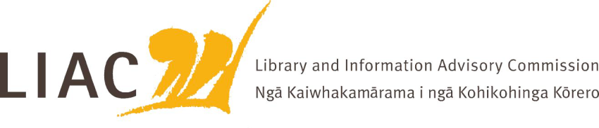

**Summary of meeting – 30 July 2024**

The July meeting was held in Wellington, with some Commissioners joining remotely.

All Commissioners were present.

1. **Te Pouhuaki National Librarian update**

* The Digitalpasifik team at NLNZ is a finalist for an award as part of the international Digital Preservation Awards, for their work on the Pacific Virtual Museum Project.
* The Collections disposal policy has been completed and signed by the Minister.
* Functional design work is progressing between NLNZ and Archives NZ
* Research findings from the Pūtoi Rito Communities of Readers initiative have been completed by NZCER. Their report is available on the National Library website. The research finds that building a culture of reading works best when it is a collaborative effort between schools, libraries, families and communities and makes the most of the national and local resources and connections available.
* AI applications in libraries are being explored between the National Libraries of New Zealand, Australia, Canada and USA.

1. **NZLII and CONZUL**

* A CONZUL representative attended to discuss further the importance of NZLII as a national resource and the need for a strengthened strategic future and sustainable infrastructure.

1. **Mātauranga Māori position statement refresh**

* LIAC will refresh and update its Mātauranga Māori position statement. It will draw on extensive work on Mātauranga Māori principles, policy and engagement undertaken by NLNZ and Archives NZ.

1. **APNK strategic future**

* A summary of options for a strengthened strategic future for APNK were shared with LIAC. The importance of APNK as a vital, low-cost network which acts as an online backbone connecting citizens to the information they need was recognised as crucially important by Commissioners. Messaging regarding its extent and potential should be strengthened.

1. **Changing role of public libraries as community hubs**

* Representatives of PLNZ, Auckland Council and formerly of LGNZ attended to update Commissioners on the changing role of public libraries, their role as community hubs, and an overview of issues facing public libraries in the current economic climate.

1. **Commission activities**

* LIAC has made a submission to the Minister of Justice regarding the Privacy Act Amendment Bill and the need for a public good exemption to be included to cover the work of cultural institutions such as libraries and museums, as is standard in similar legislation internationally.
* Recruitment of two new Commissioners is underway.